**USER REQUIREMENTS SPECIFICATIONS**

**PRJ-CB04**

GROUP 3



23rd February 2021

**Members :**

Joran van de Moosdjik (400000) - <j.vandemoosdijk@student.fontys.nl>

Jordy Rutjens (3946975) - <j.rutjens@student.fontys.nl>

Shanessa Kostaman (450080) - <genoveva.shanessakostaman@student.fontys.nl>

Tobias Agyasta Halomoan (4252861) - <t.halomoan@student.fontys.nl>

**Tutors :**

Kalina Petrova (as a mentor) - <k.petrova@fontys.nl>

Frank de Lepper (as a client) - <f.delepper@fontys.nl>

**Fontys University of Applied Sciences**

**Eindhoven – Netherland**

**2020-2021**

Table of Contents

**Agreements with Client** 22

Functional Requirements 23

Current User Cases 23

GUI 23

Website Wireframe 23

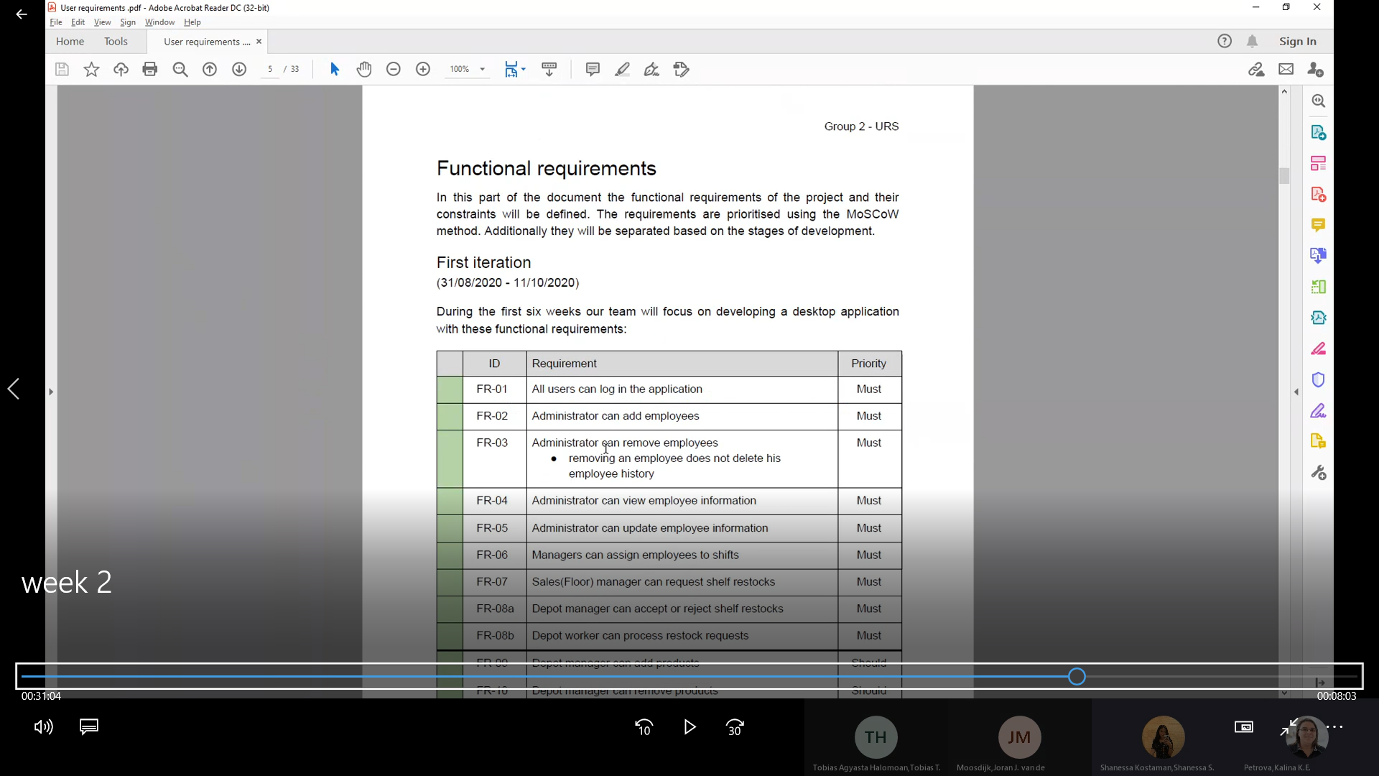

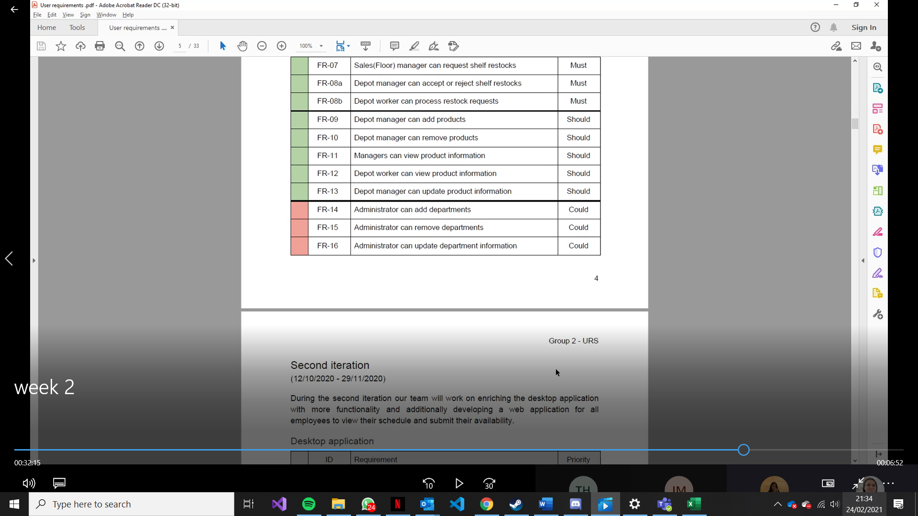

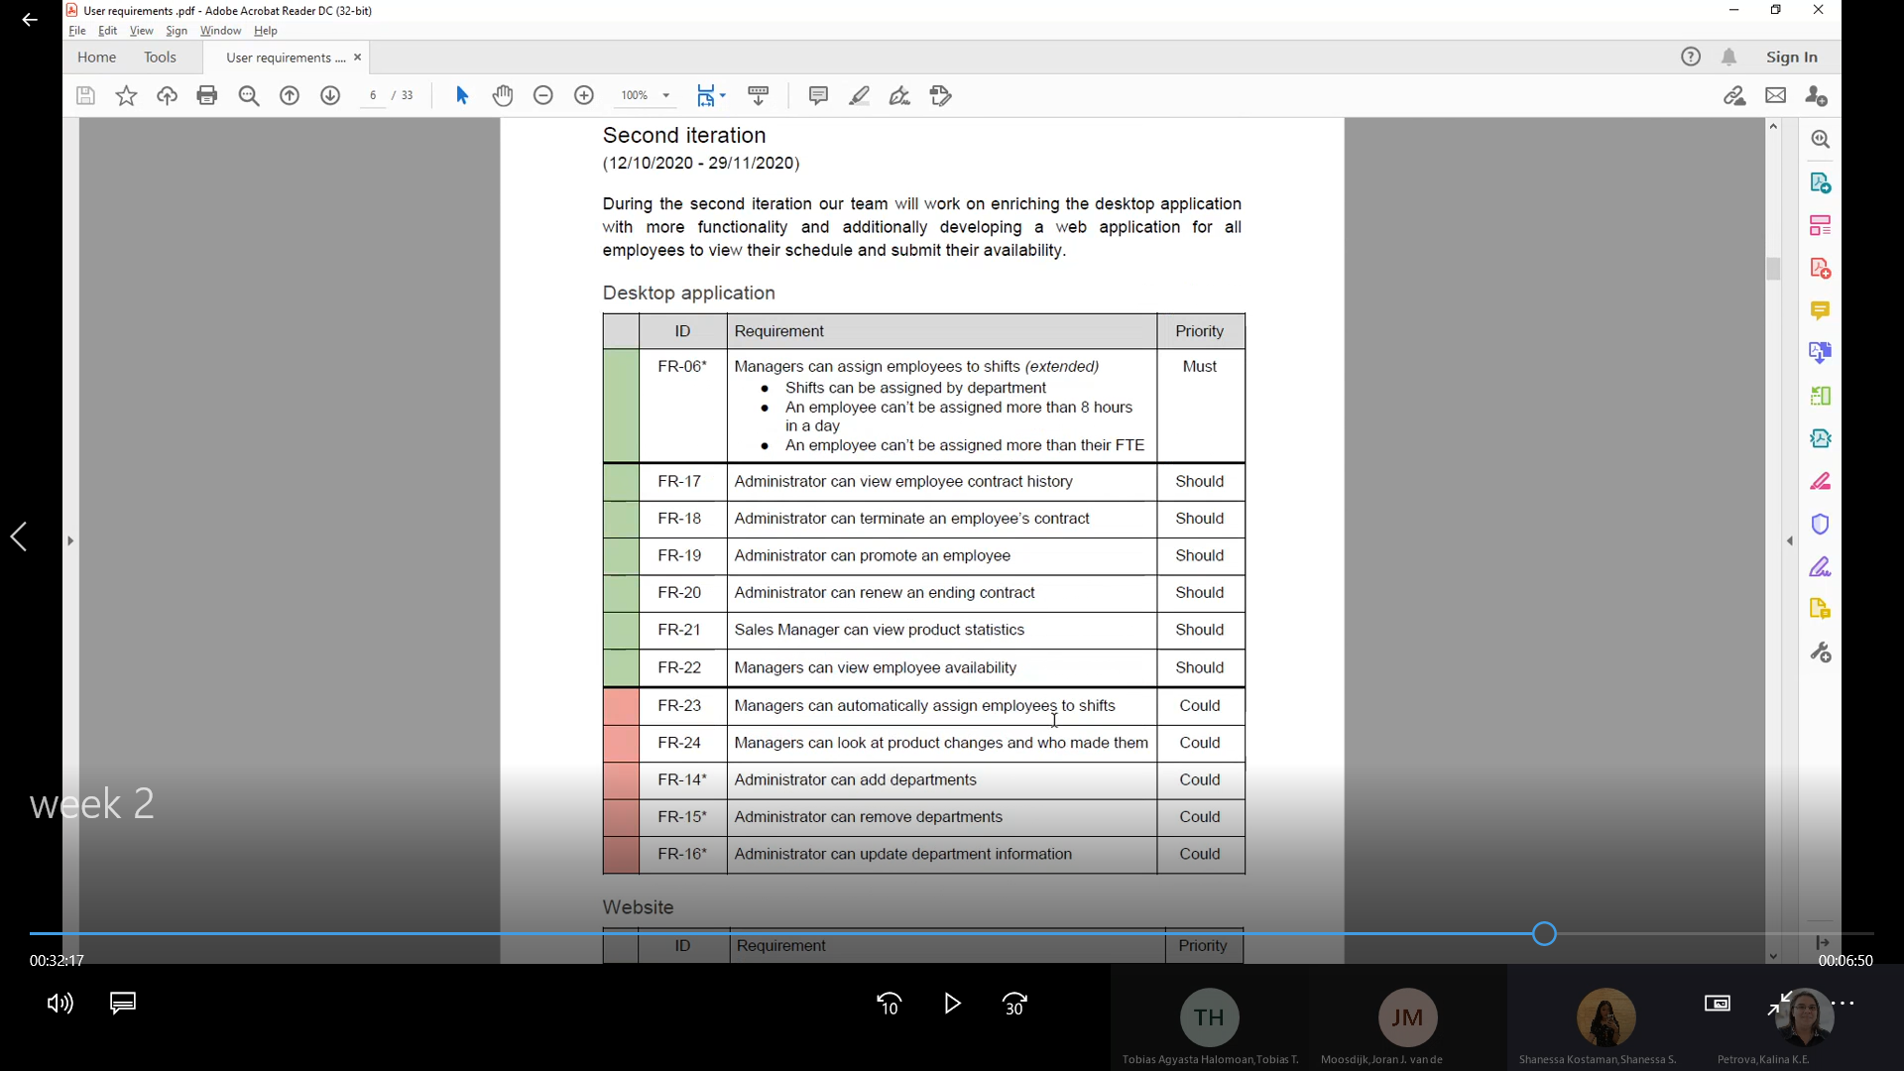

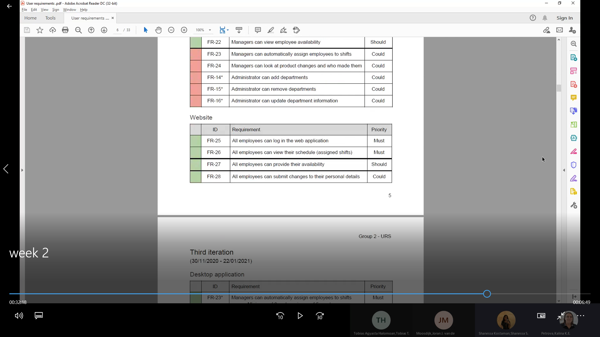

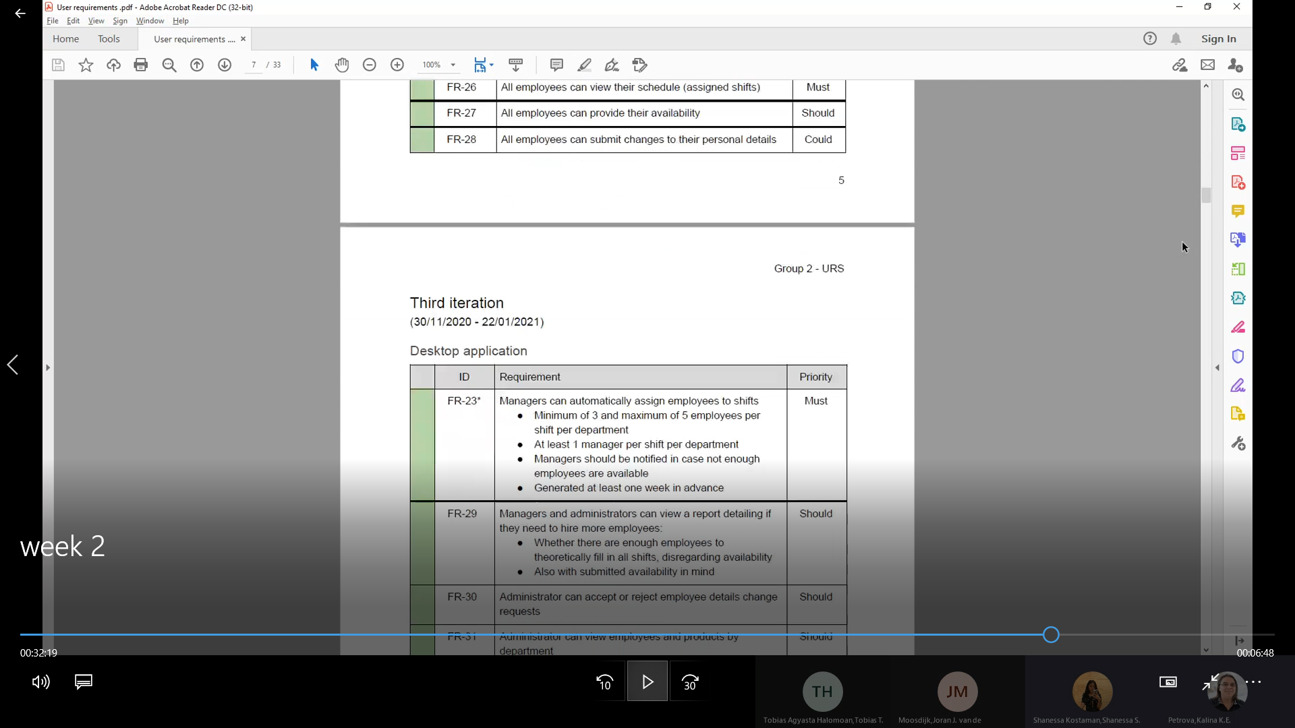

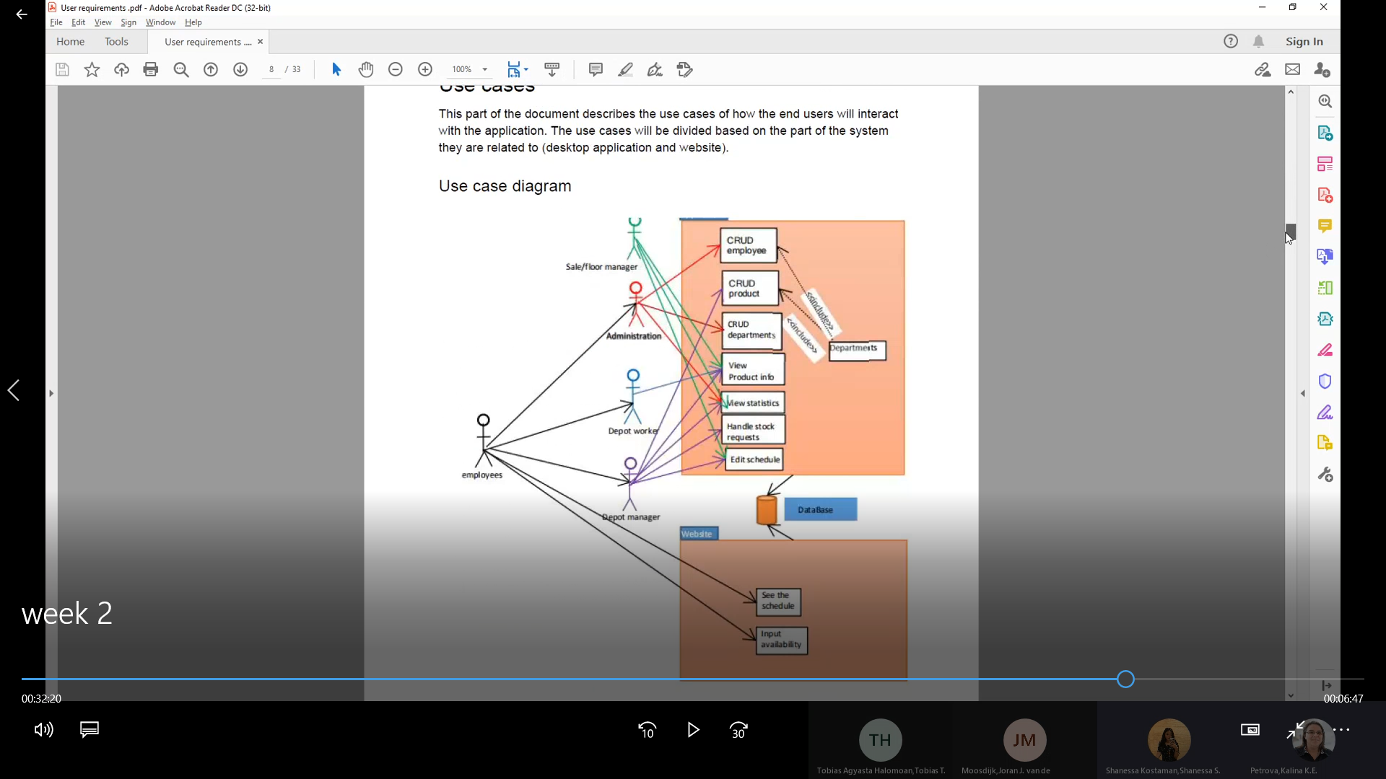

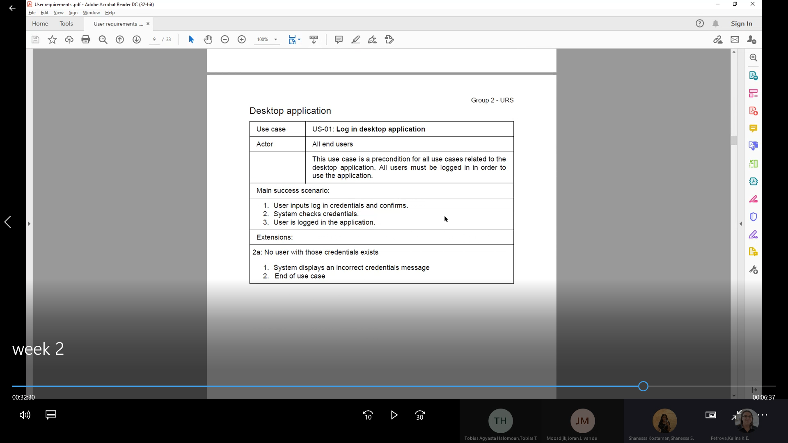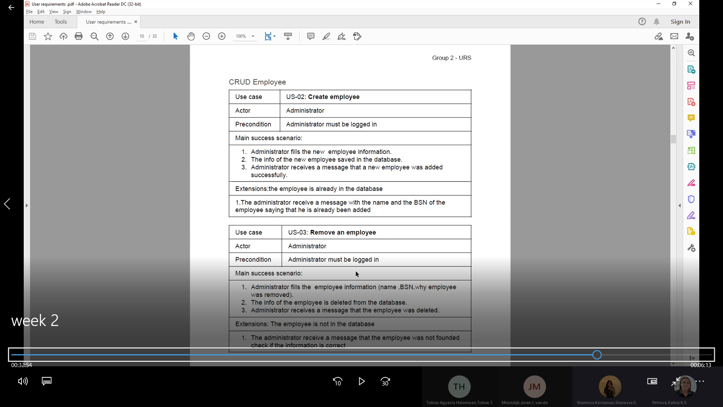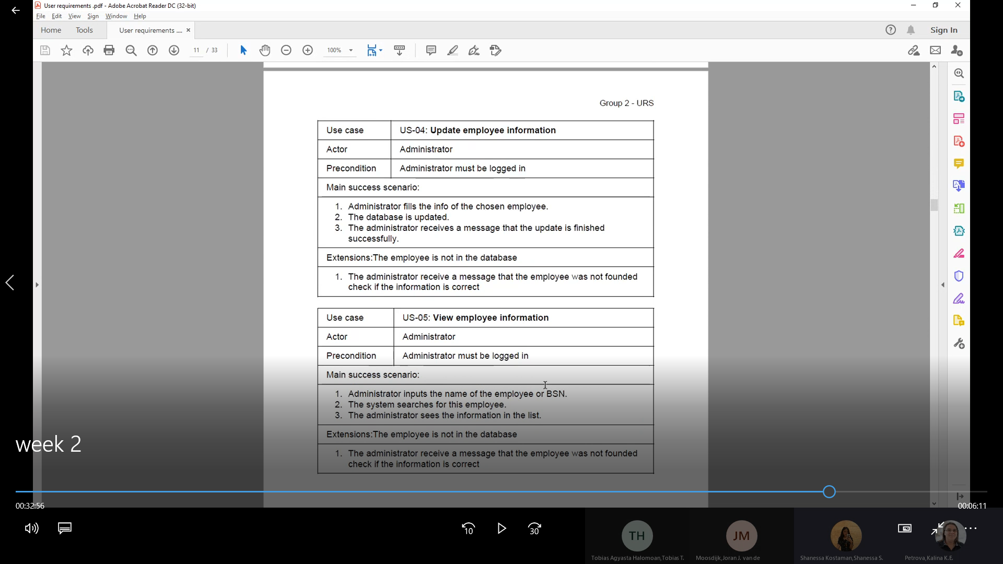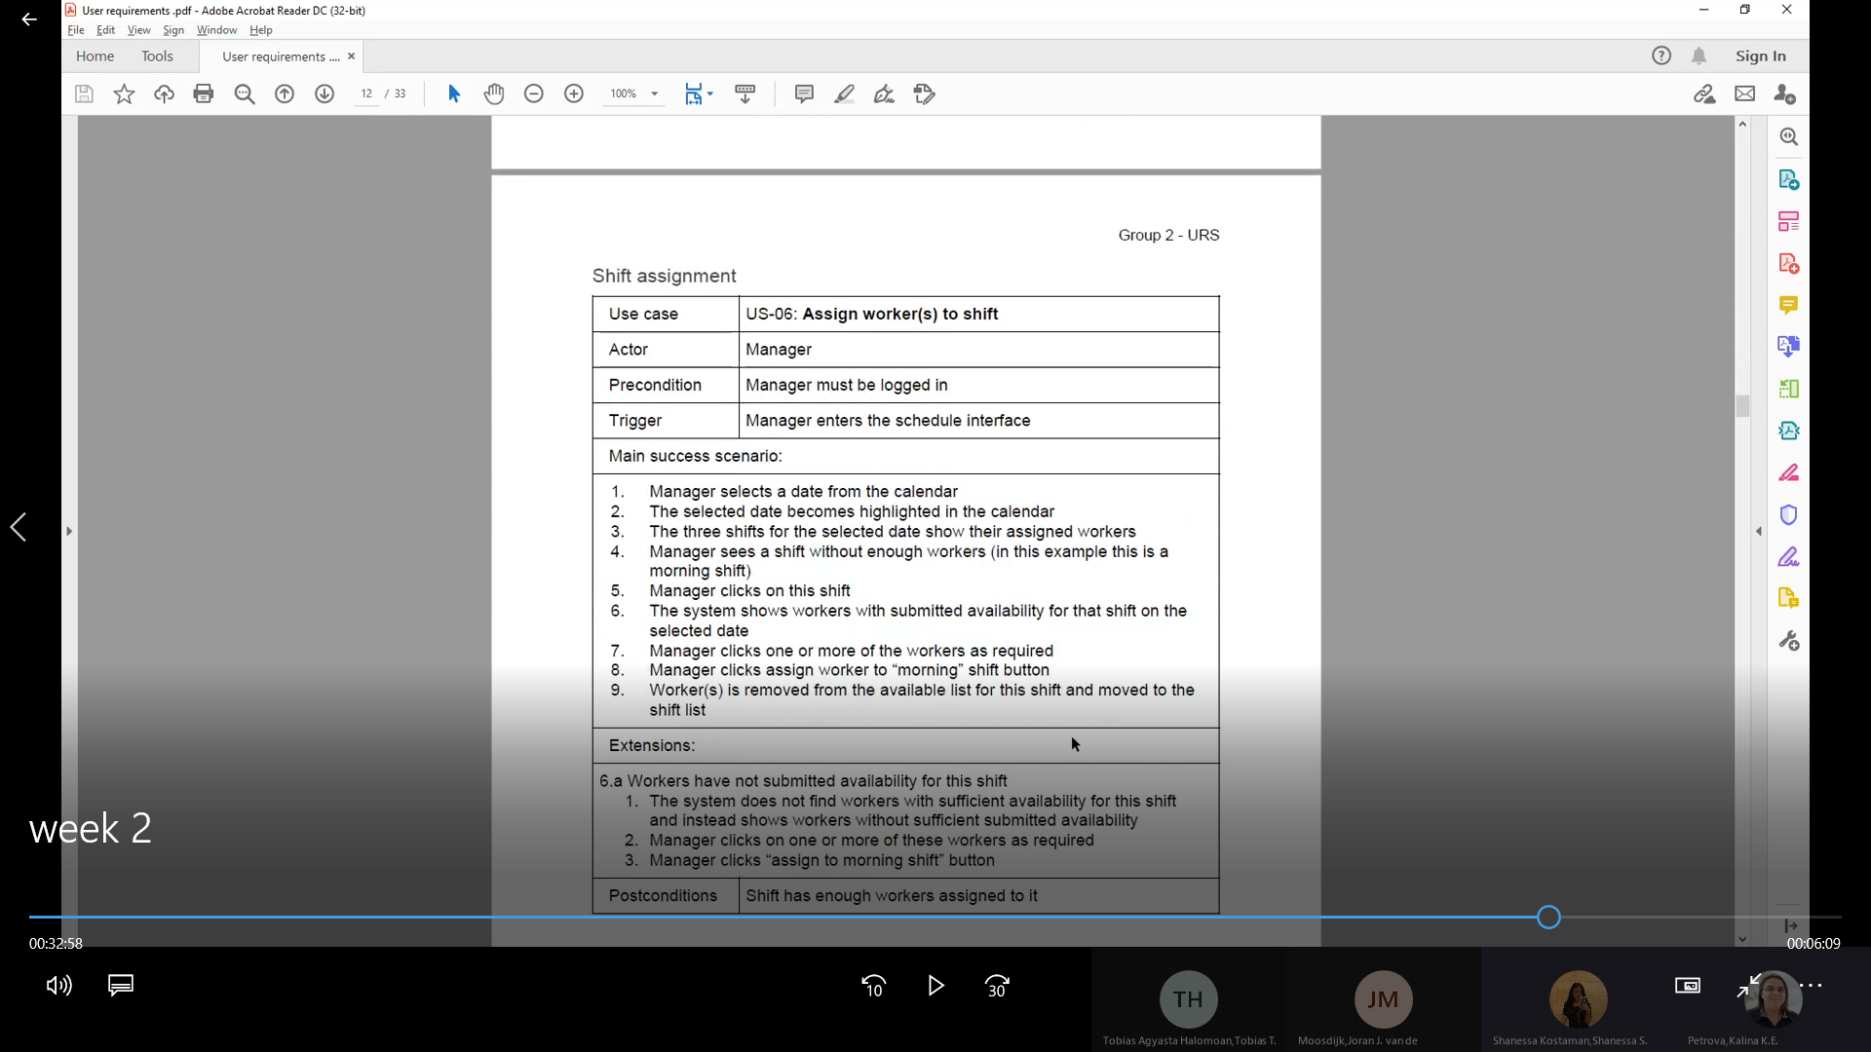

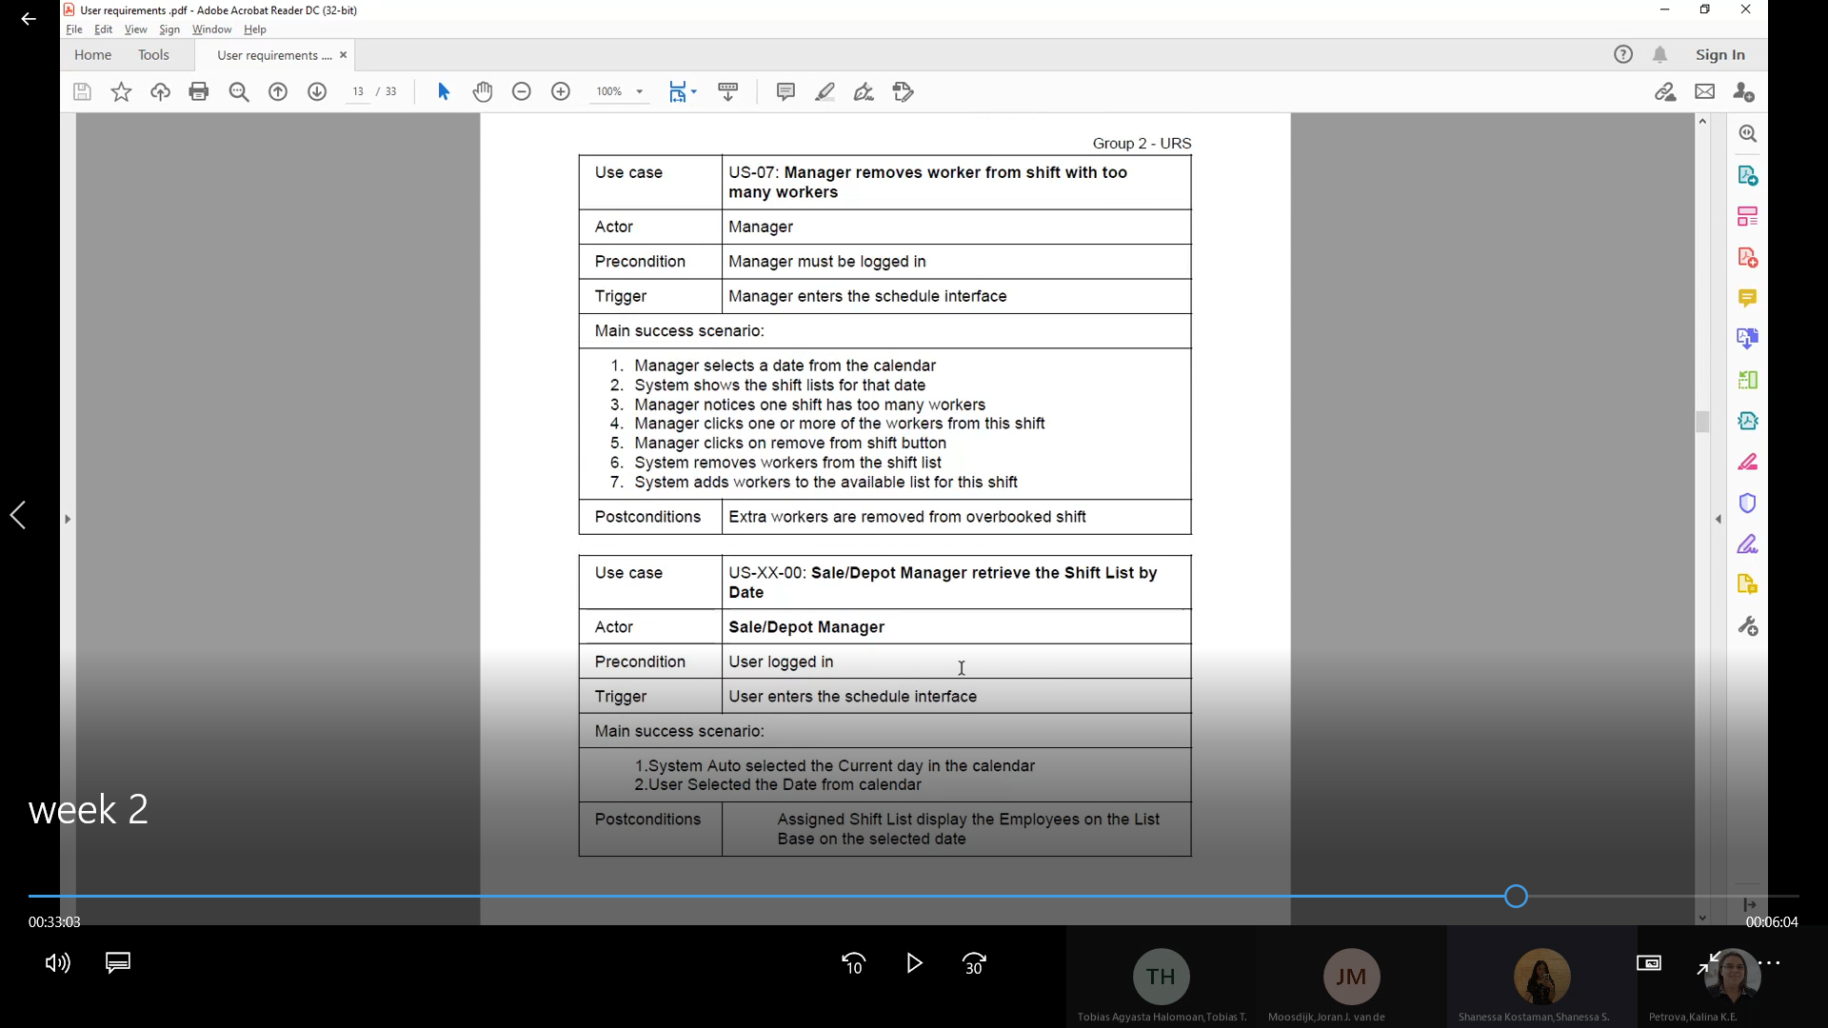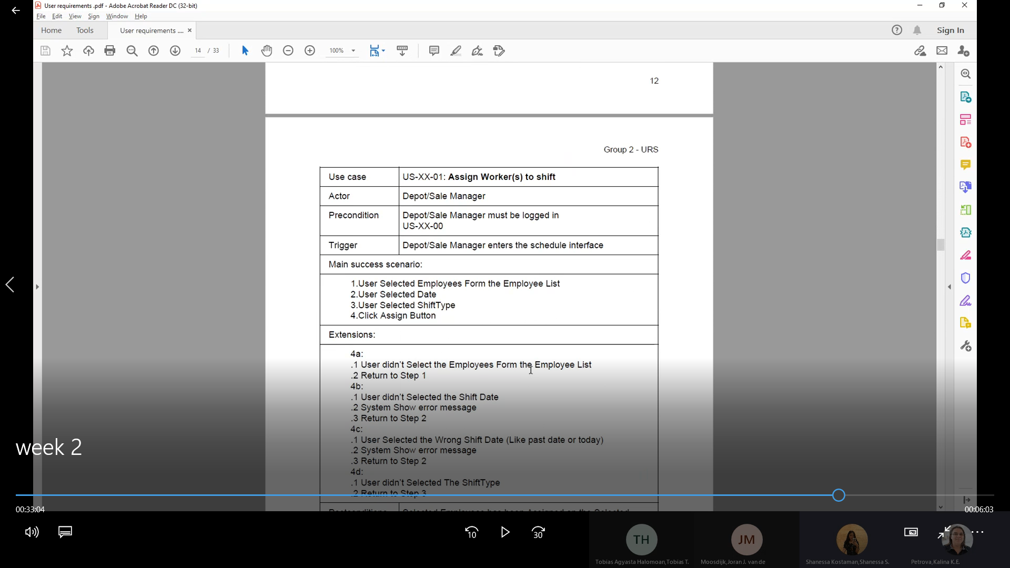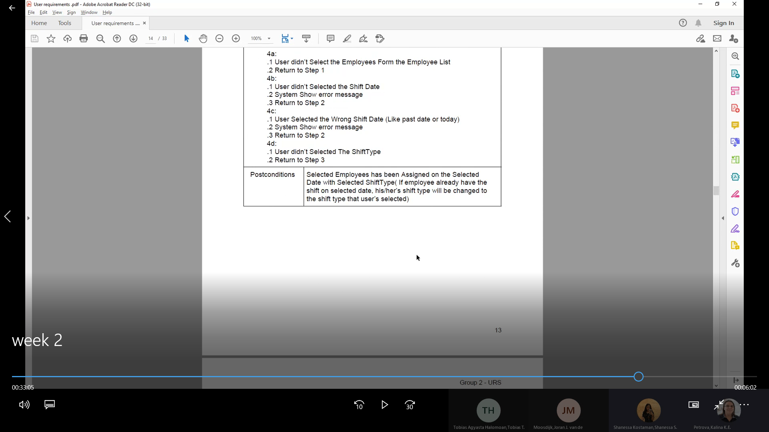

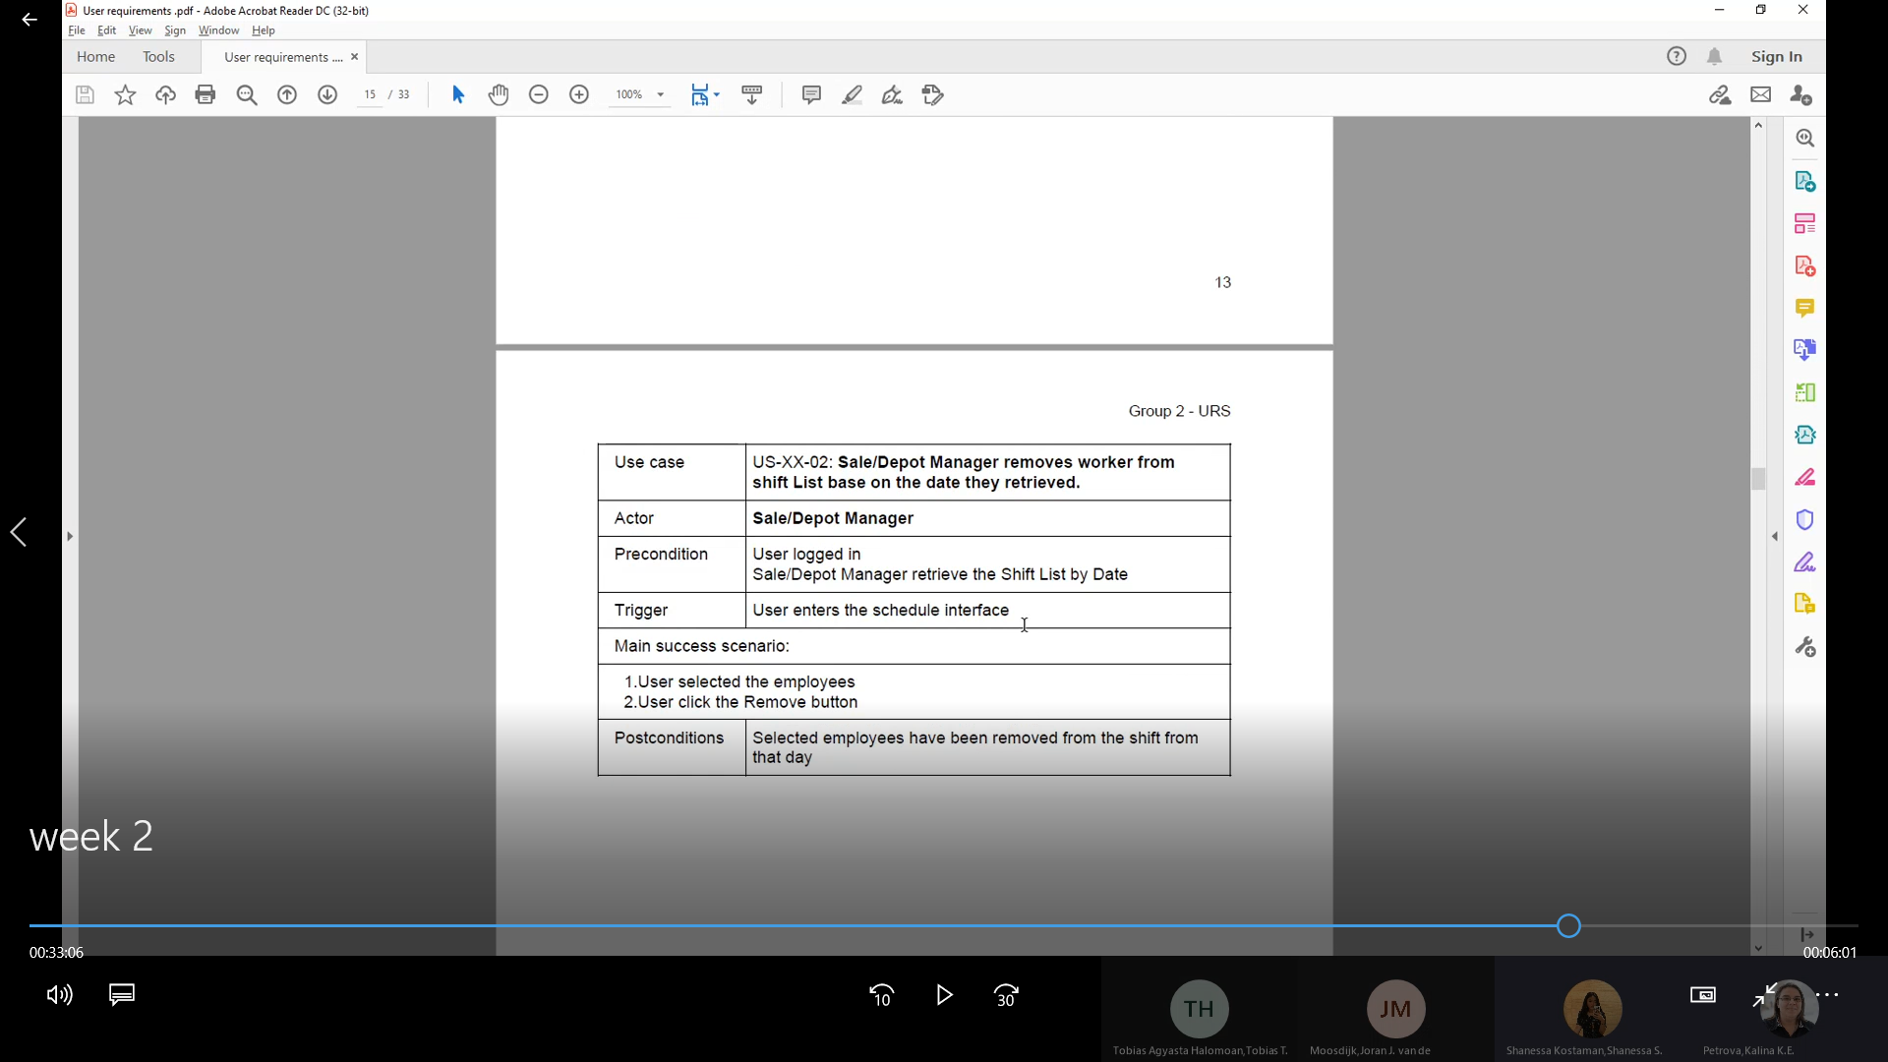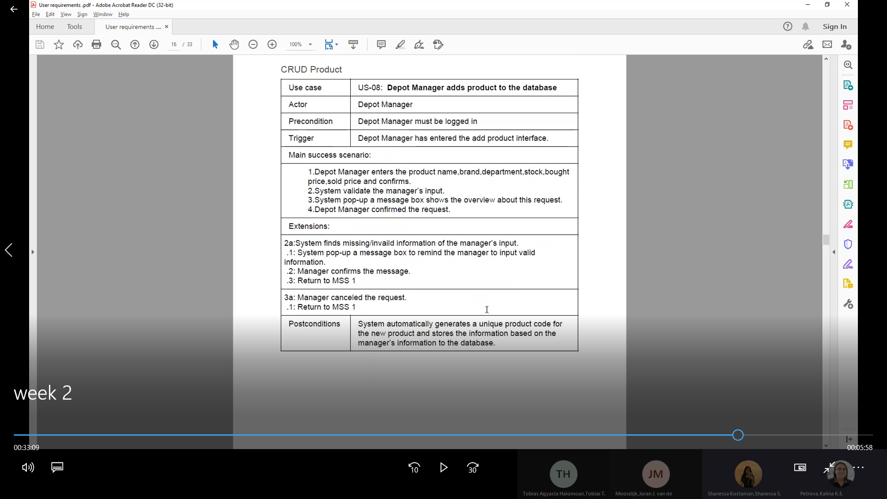

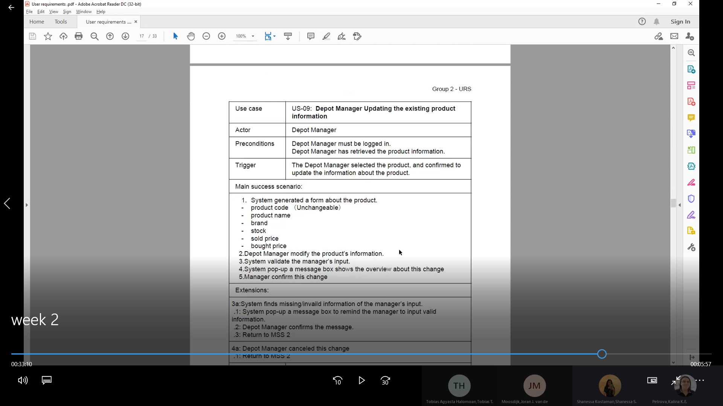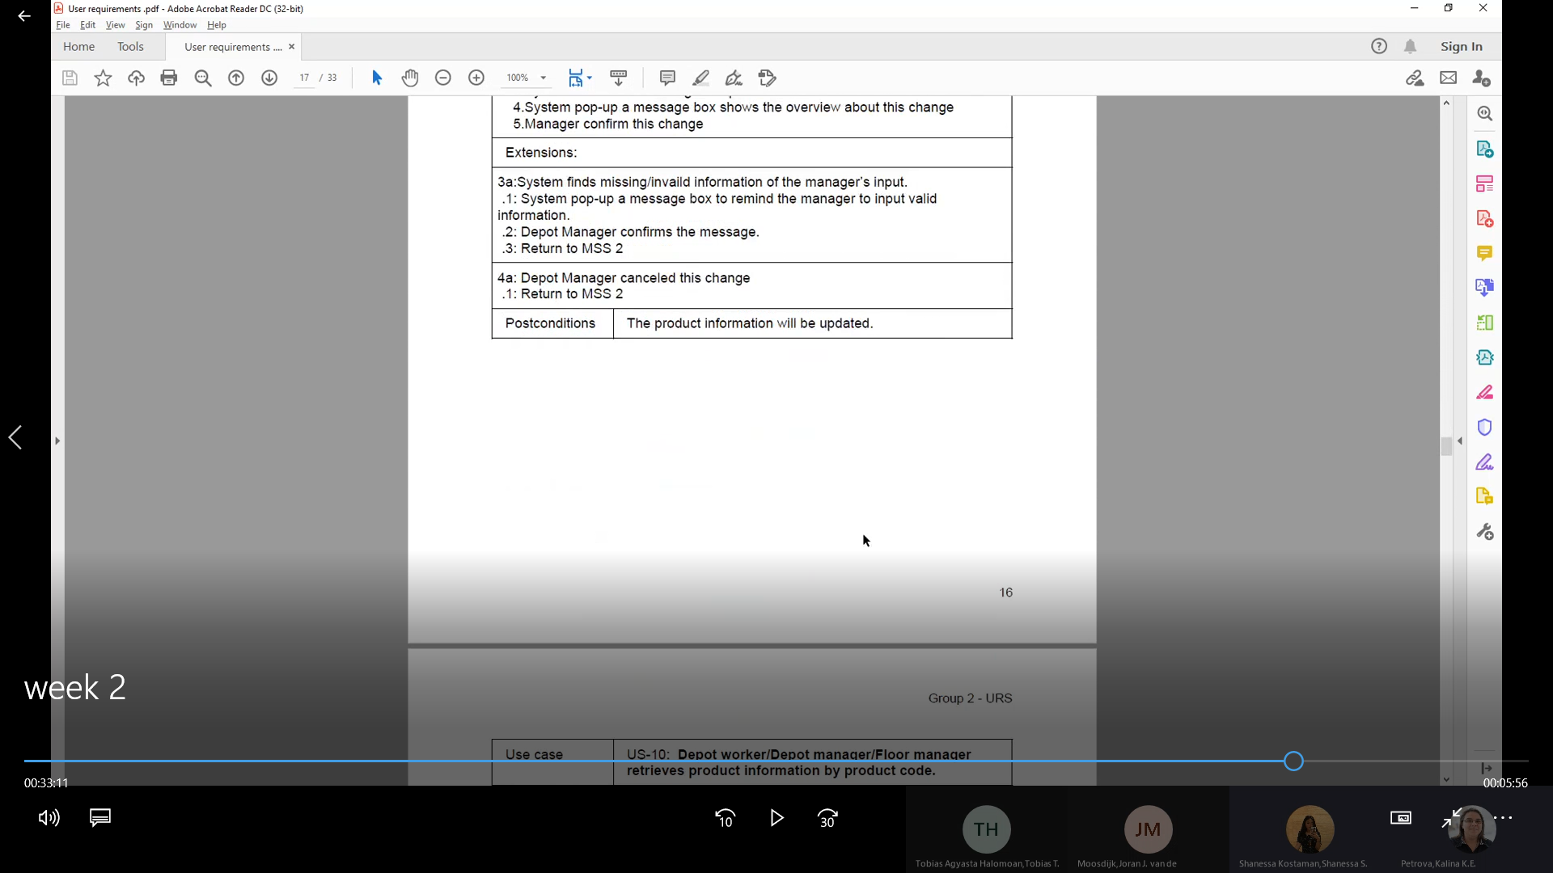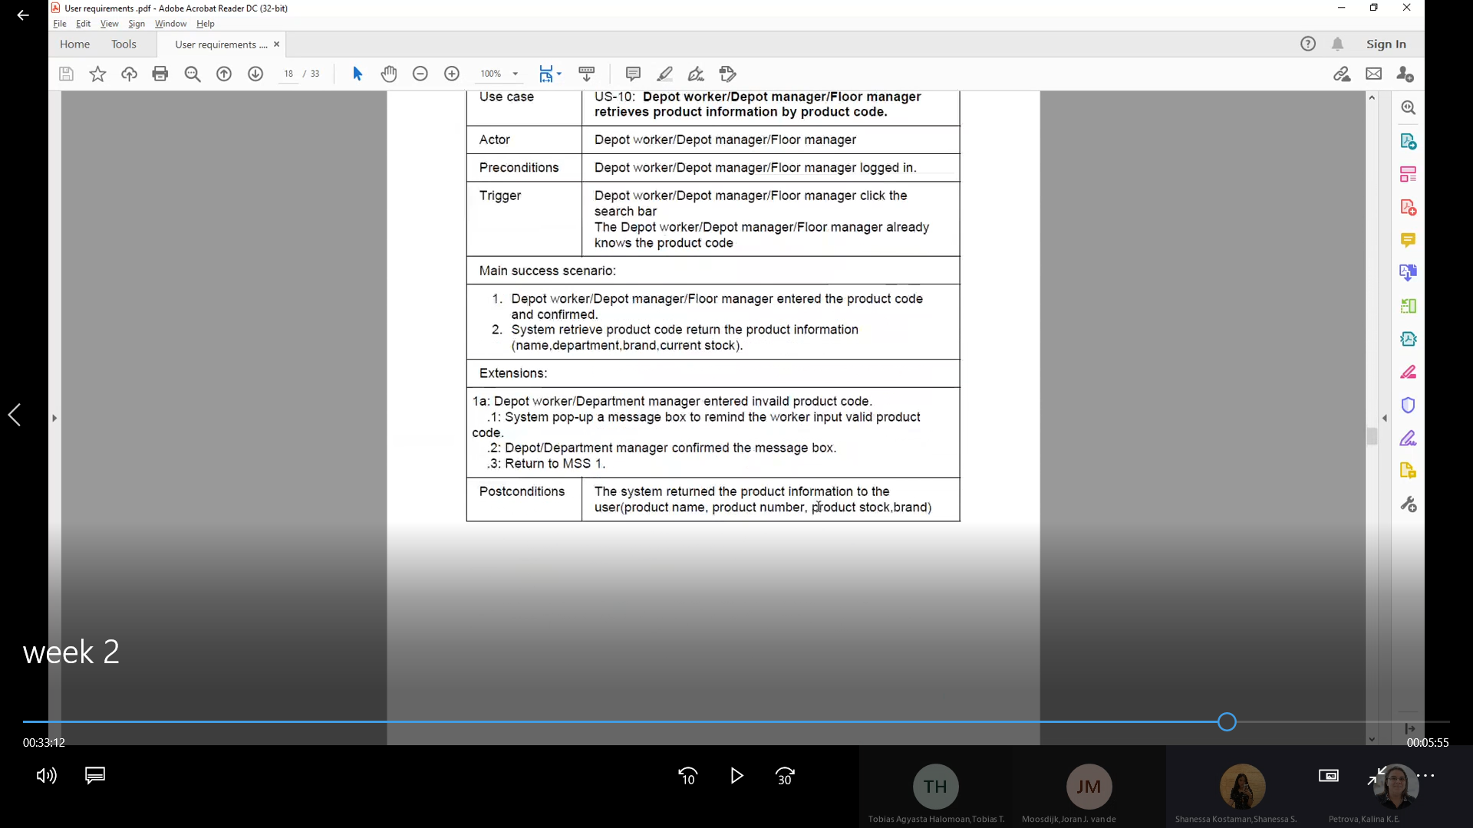

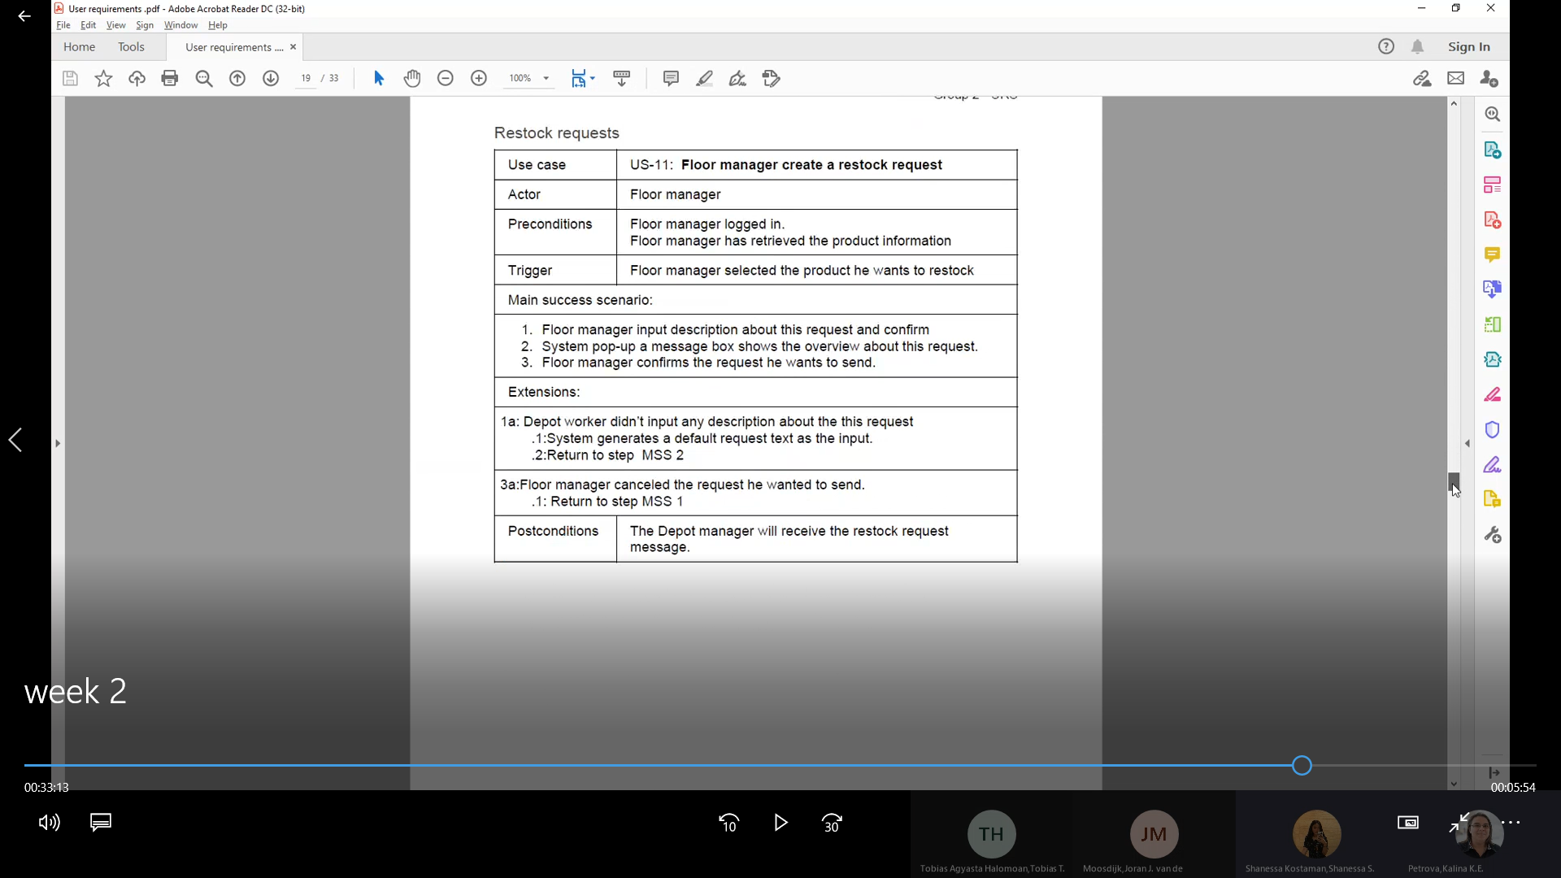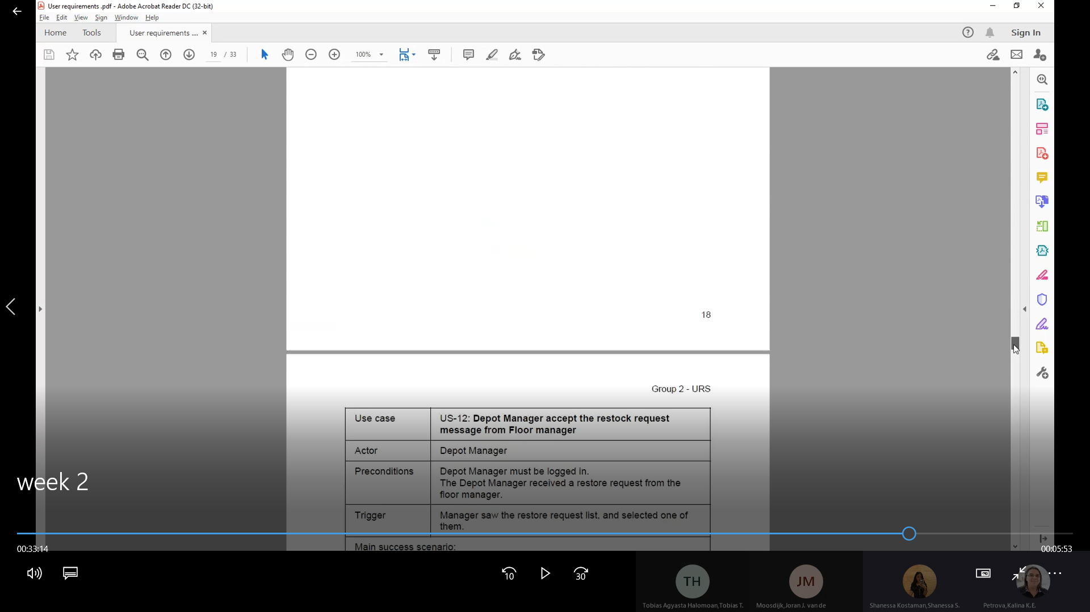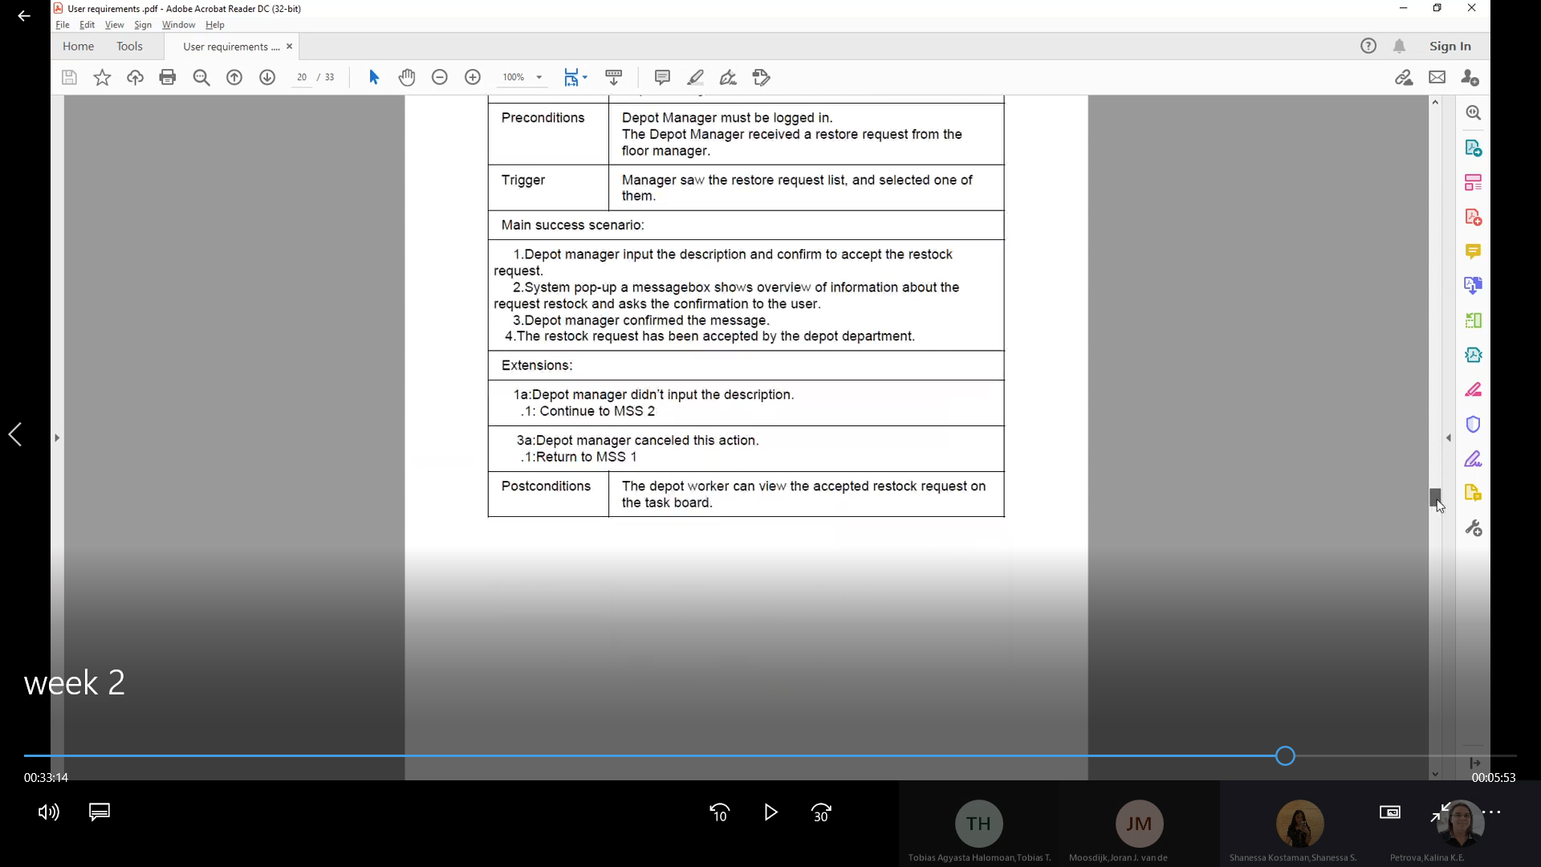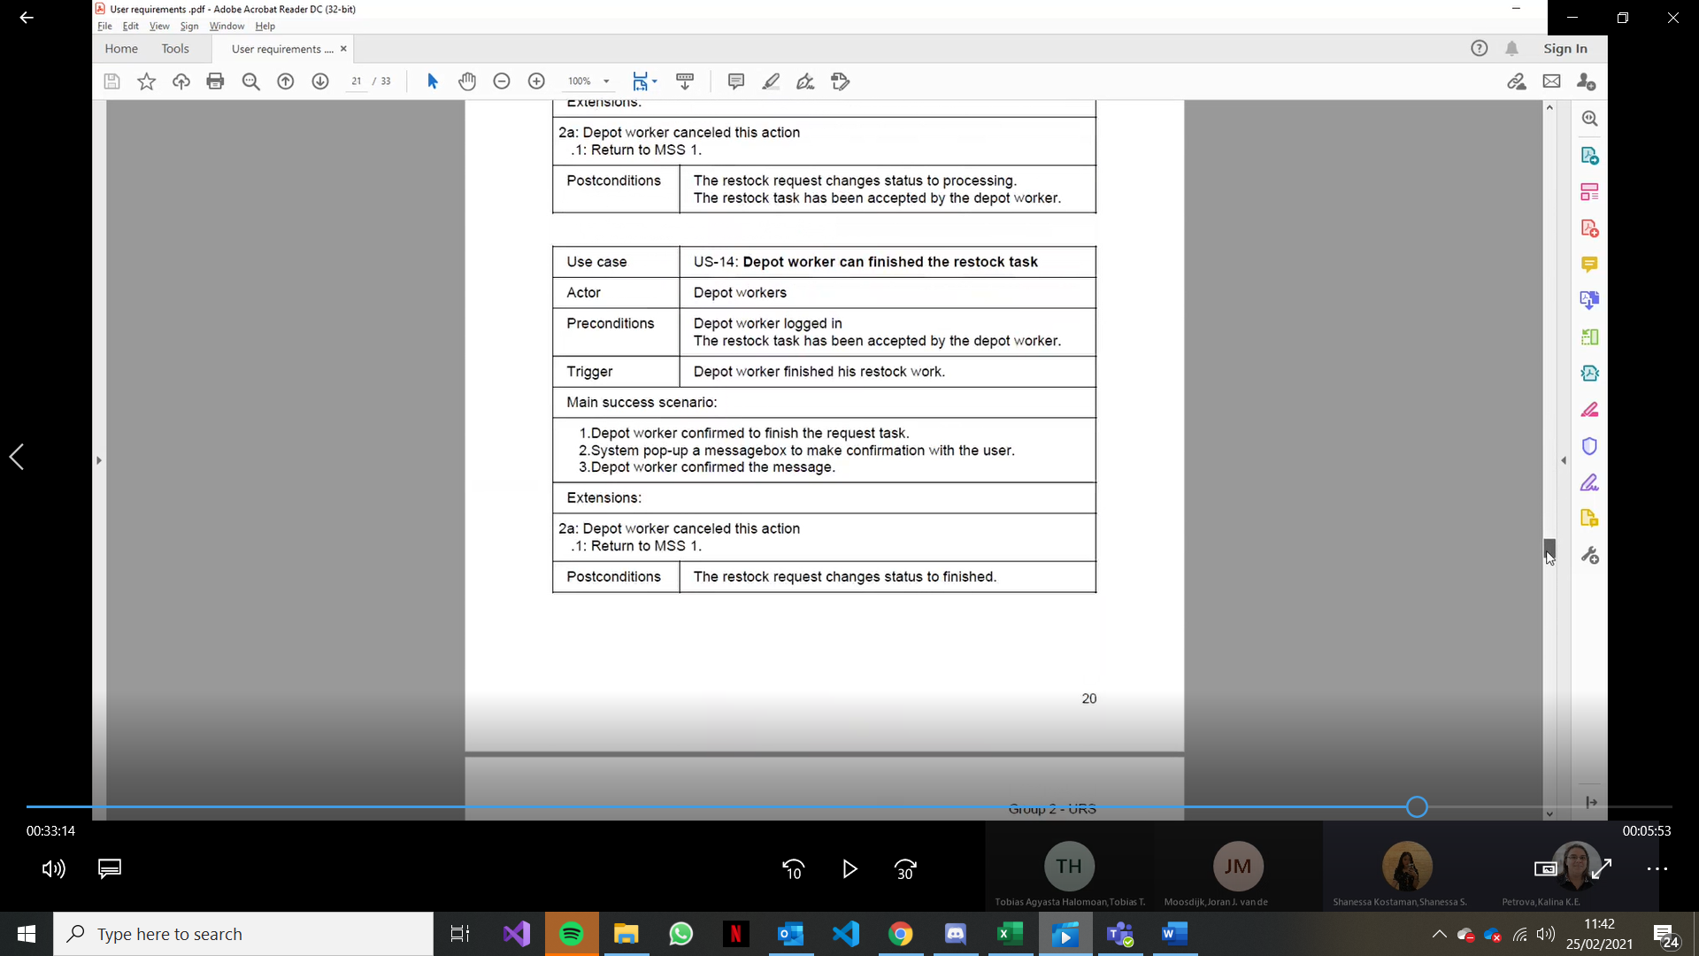

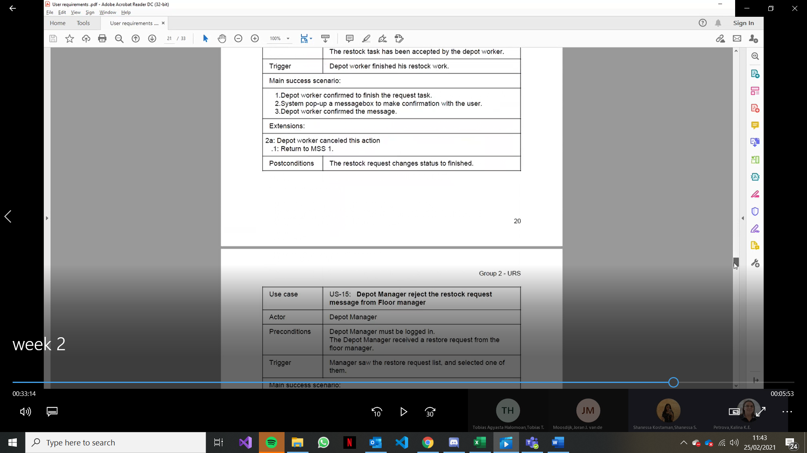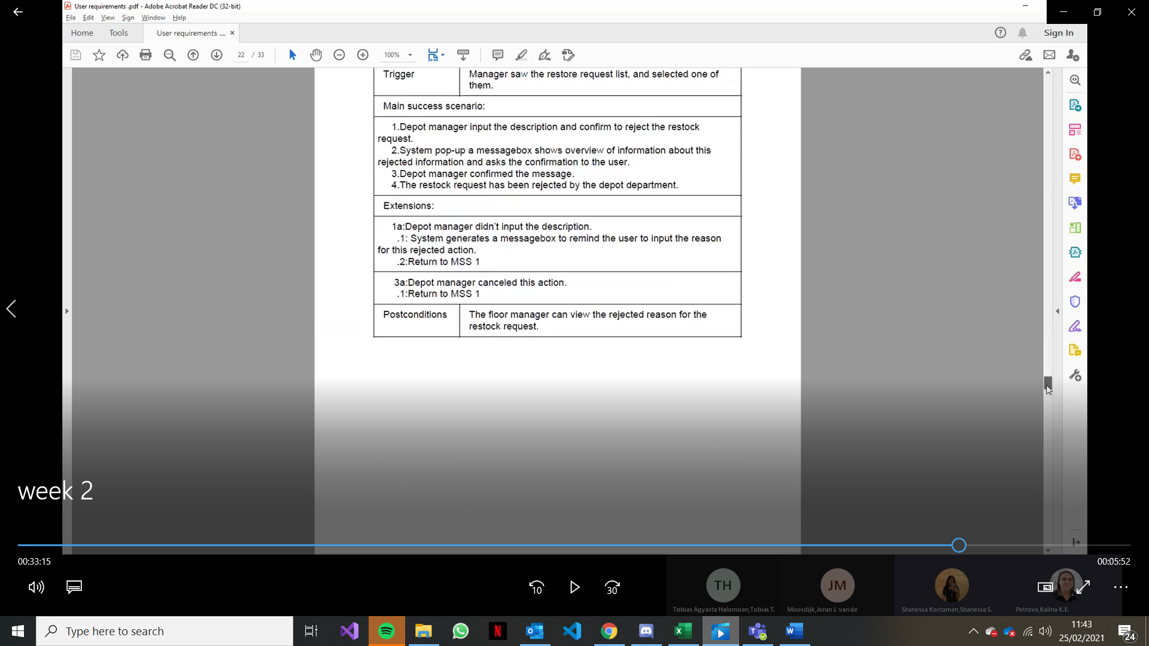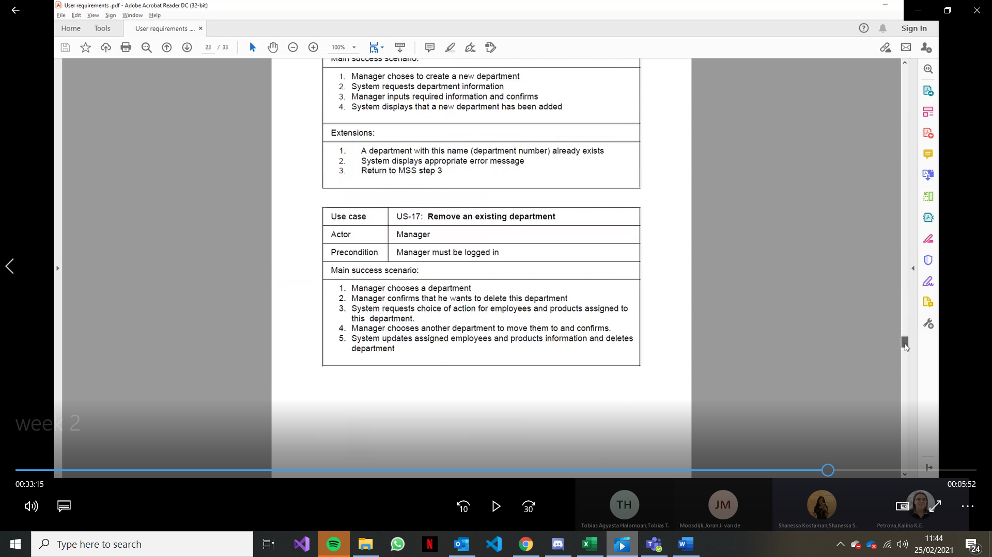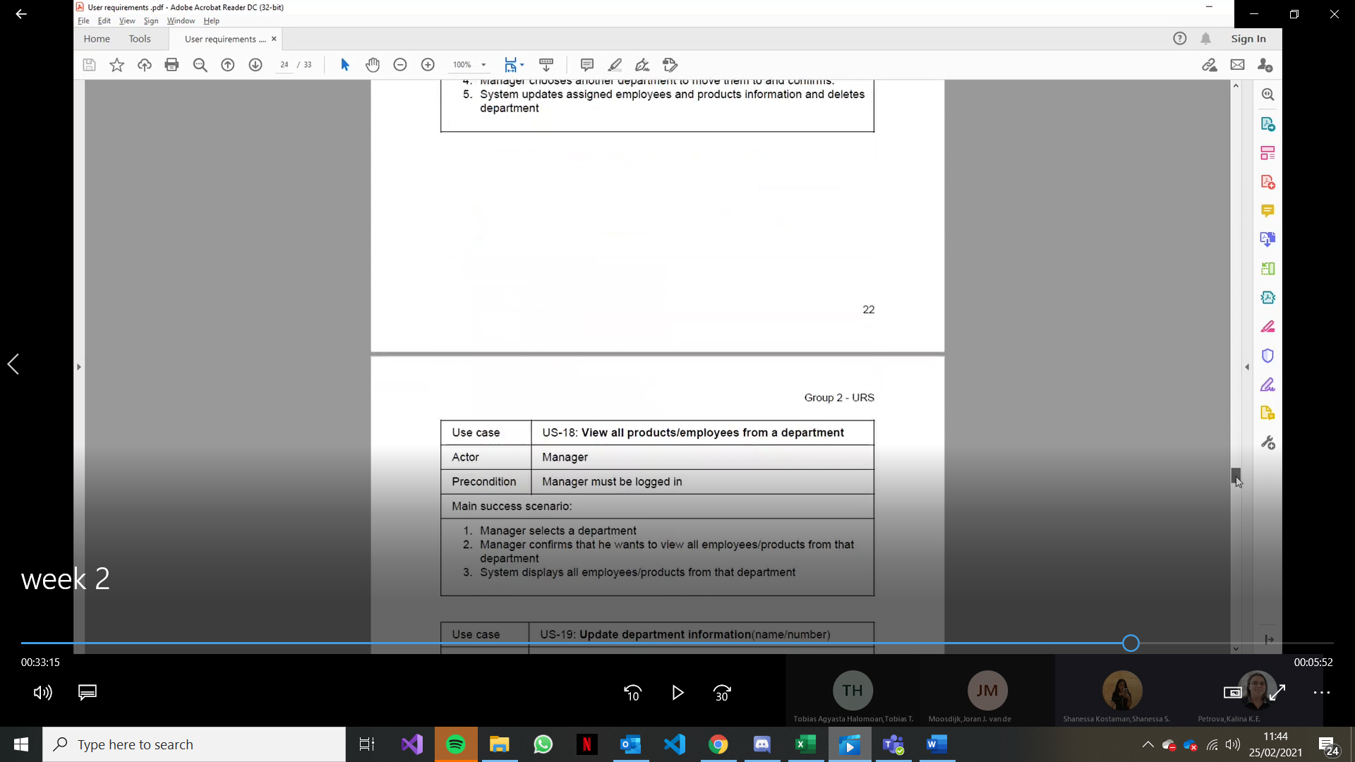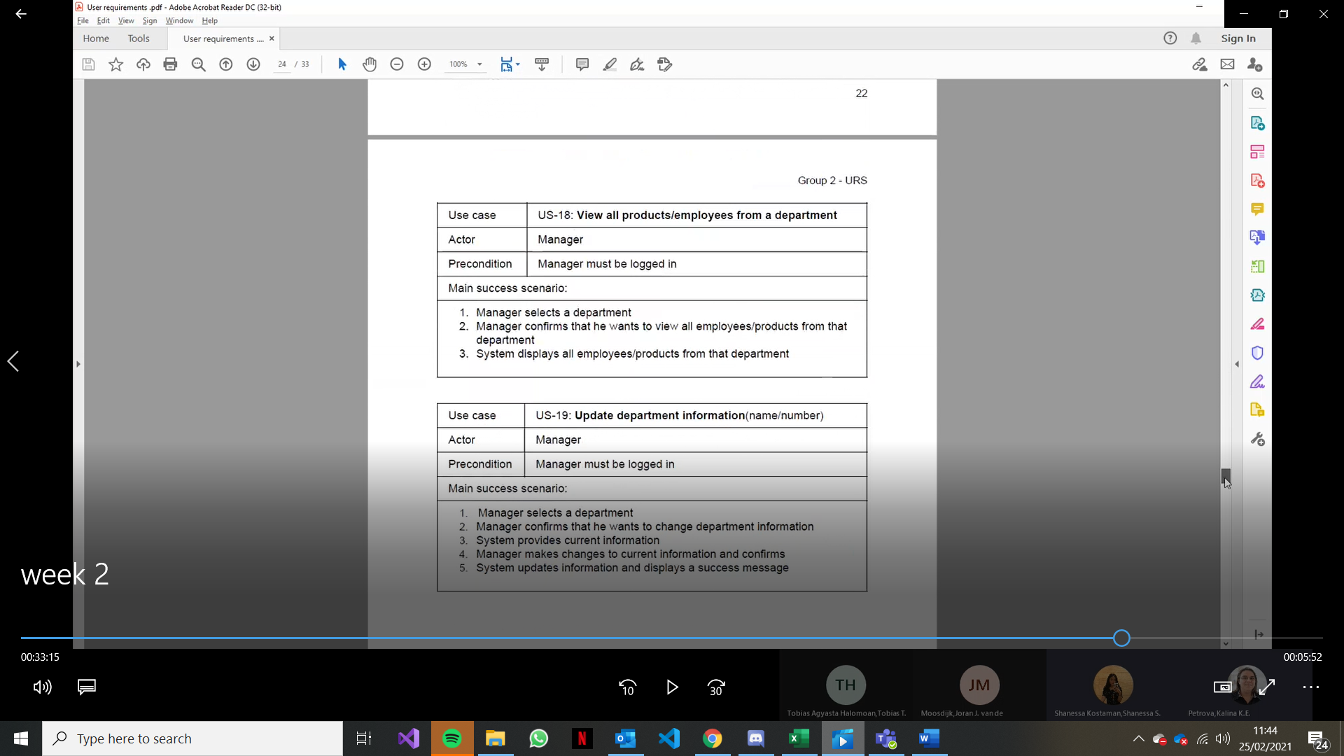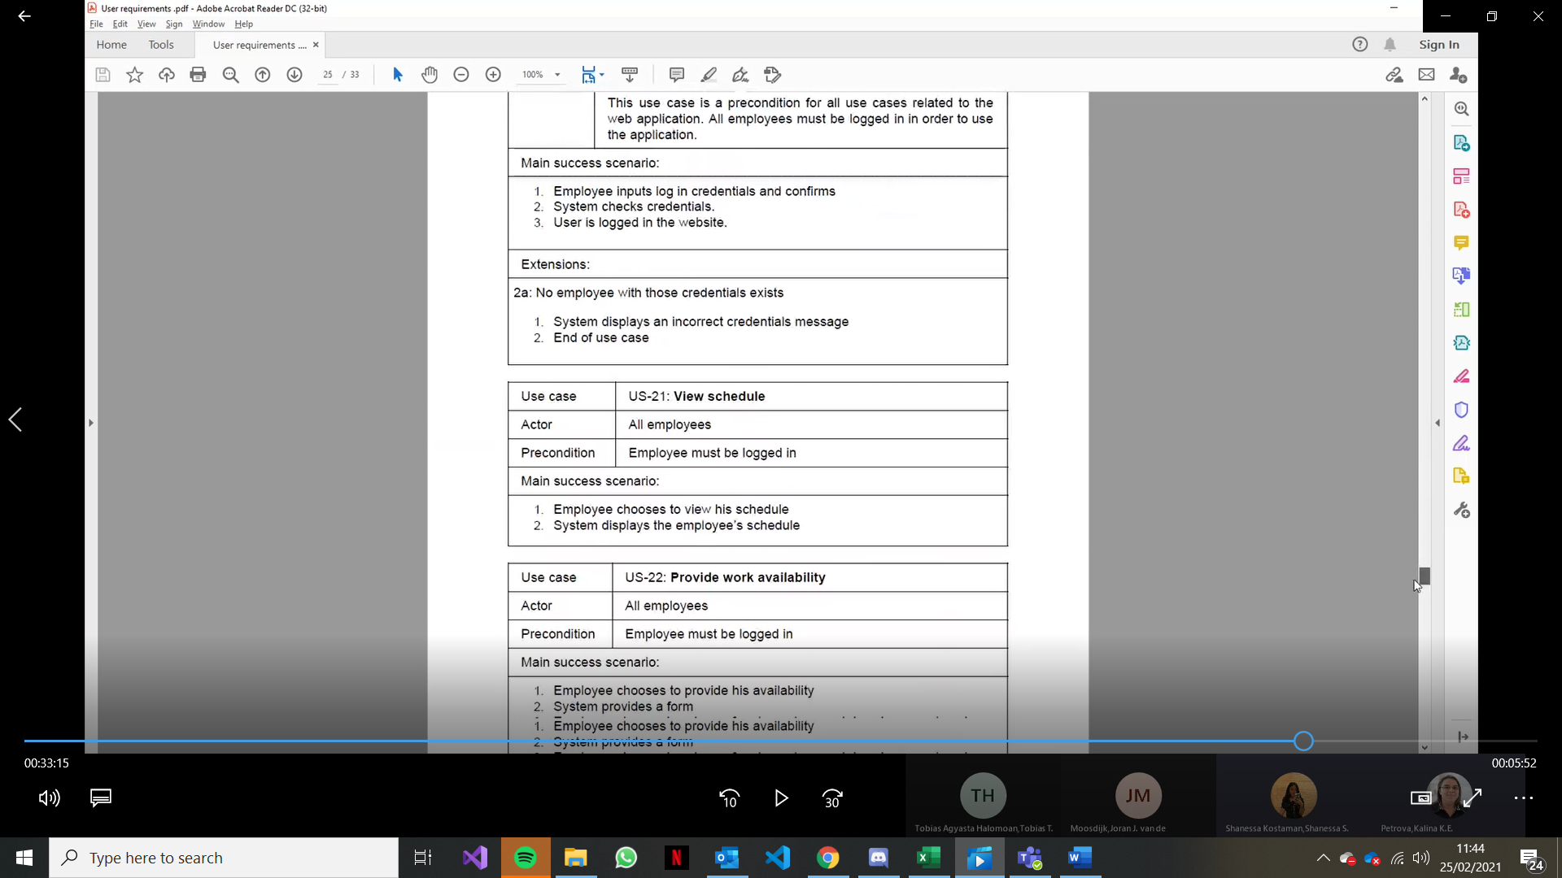

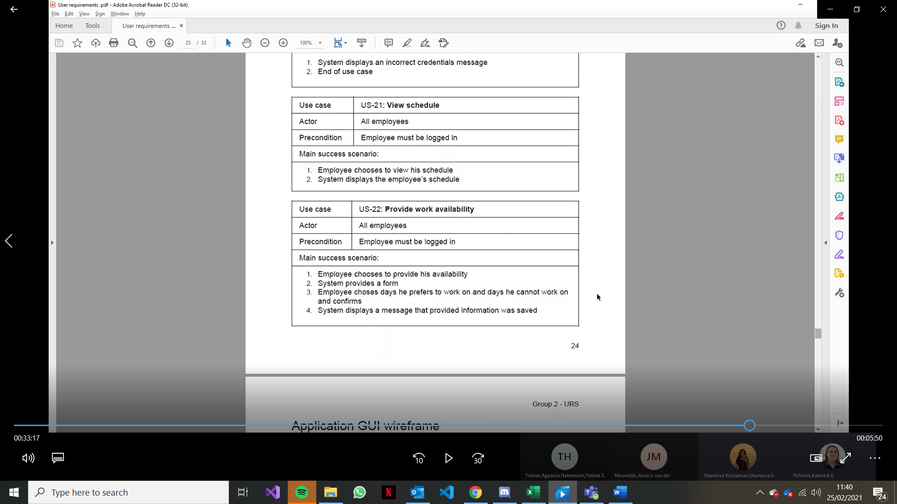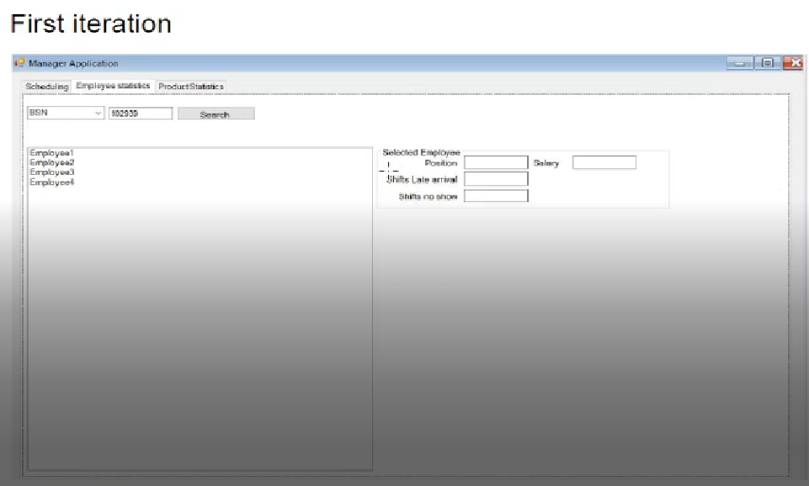

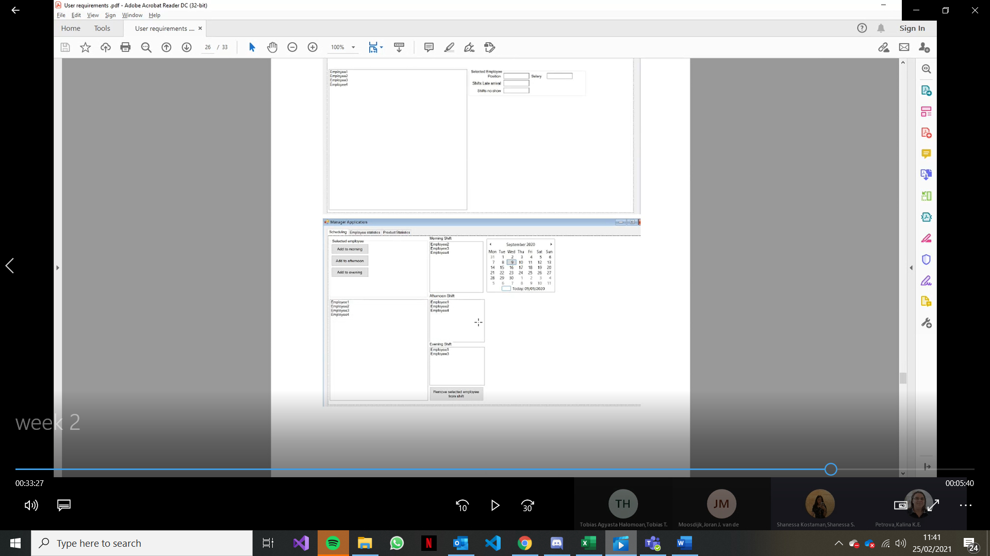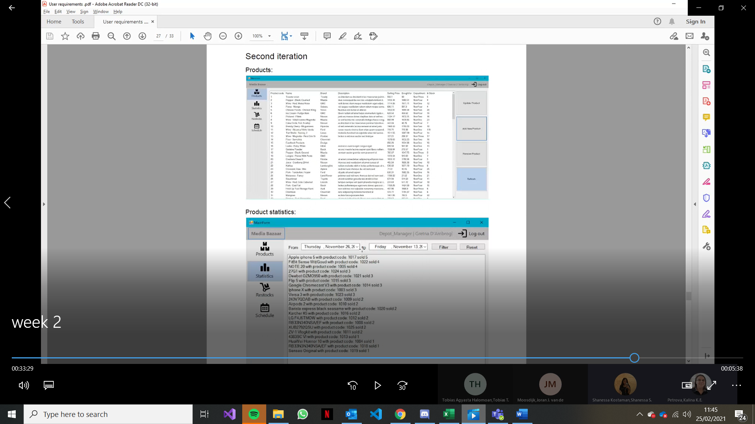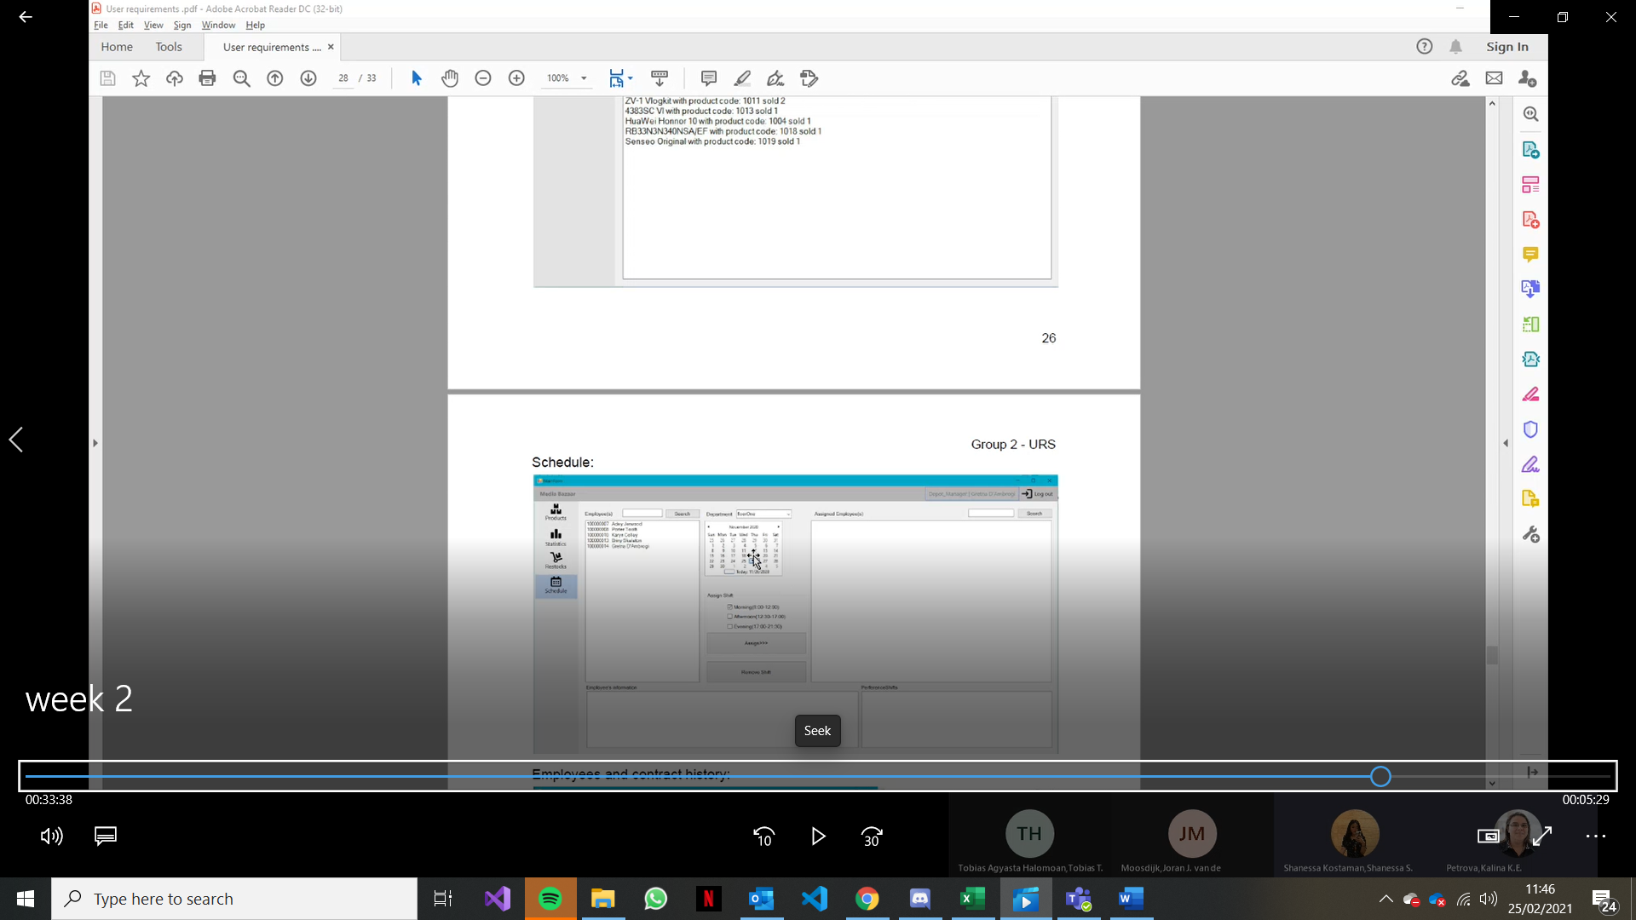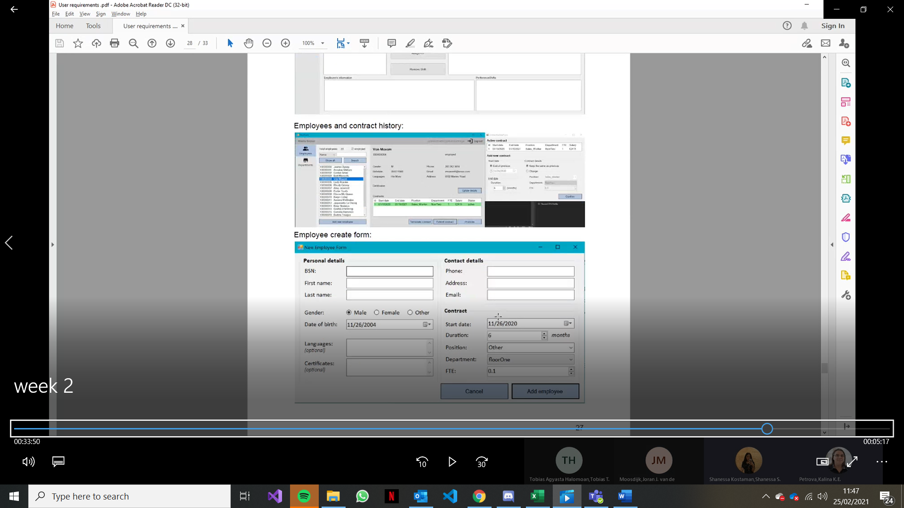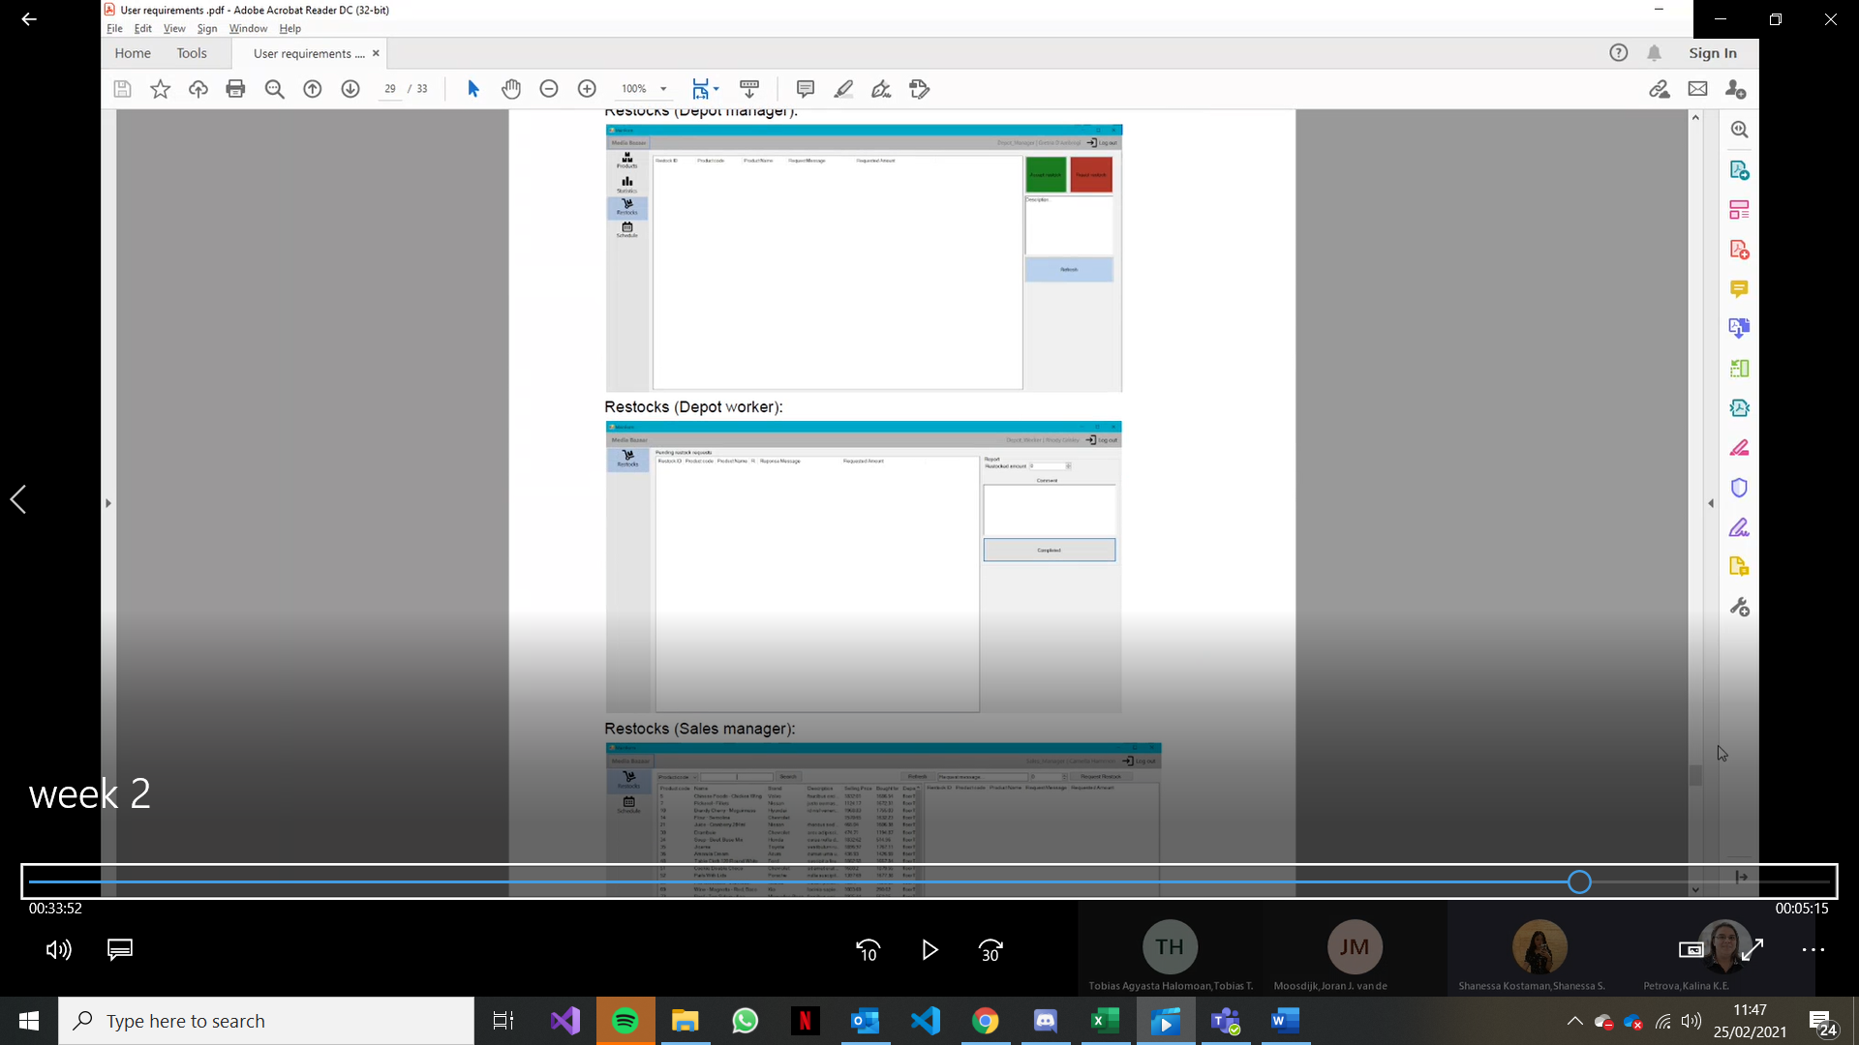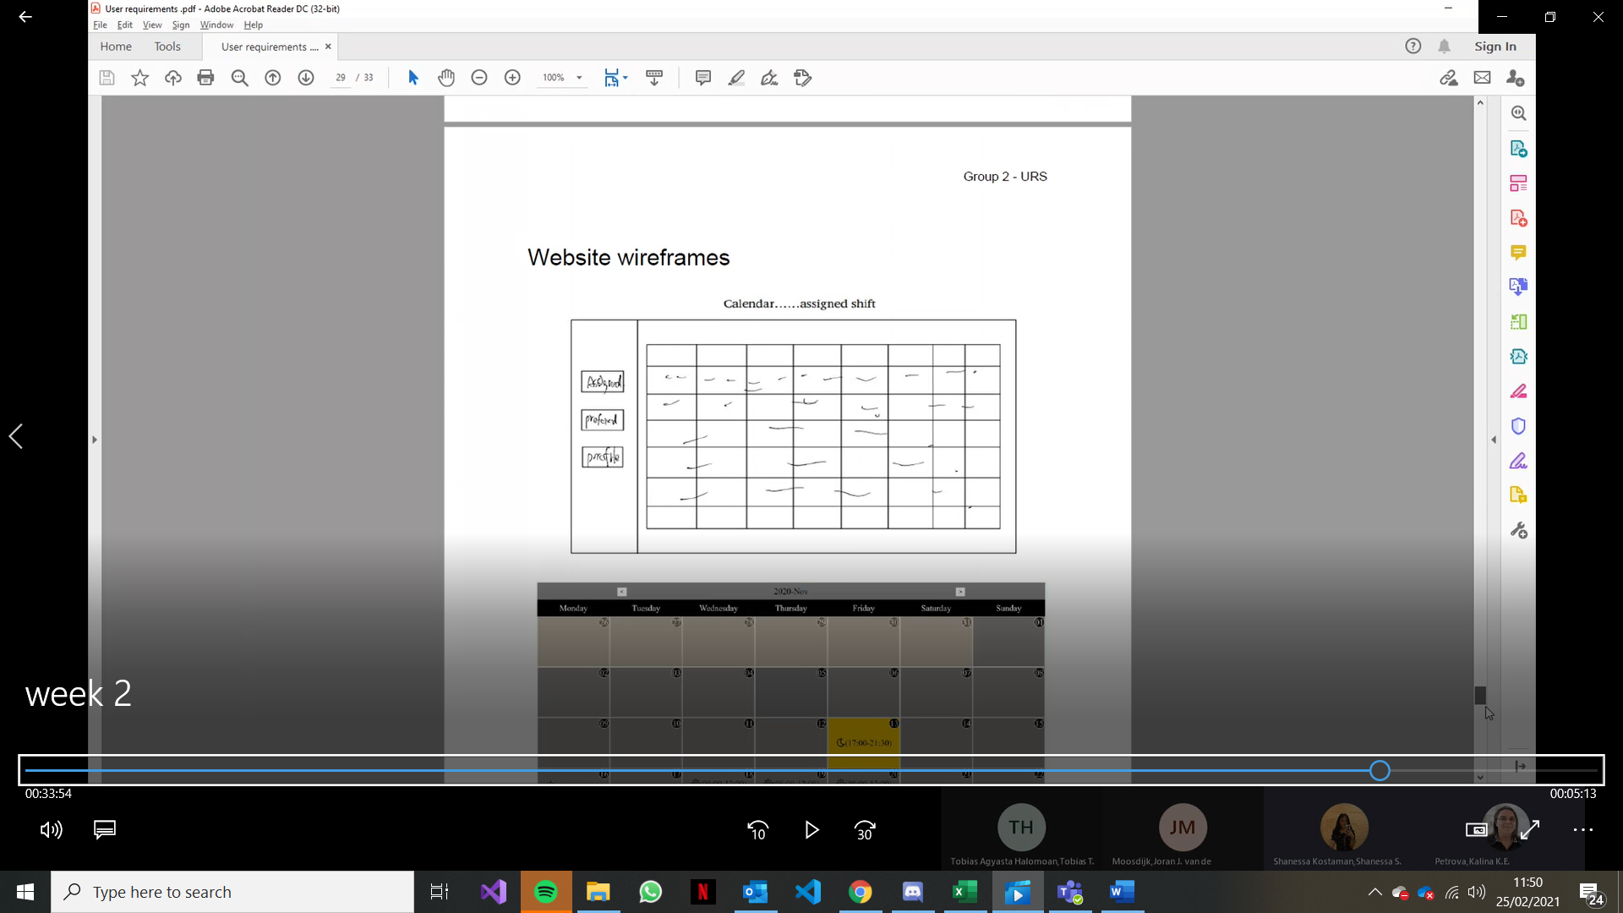

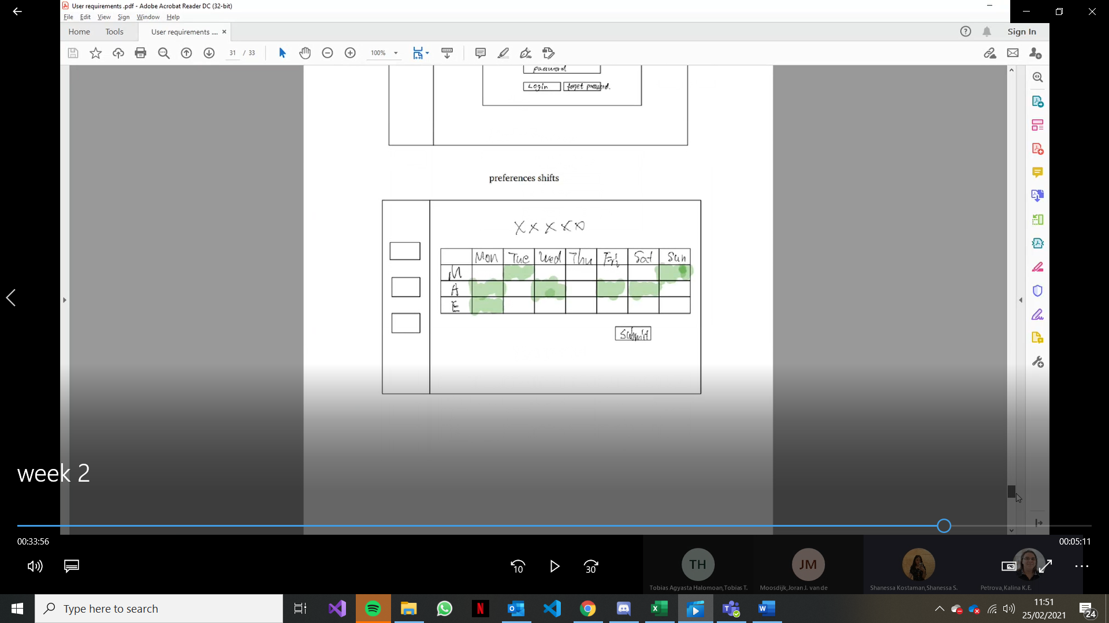

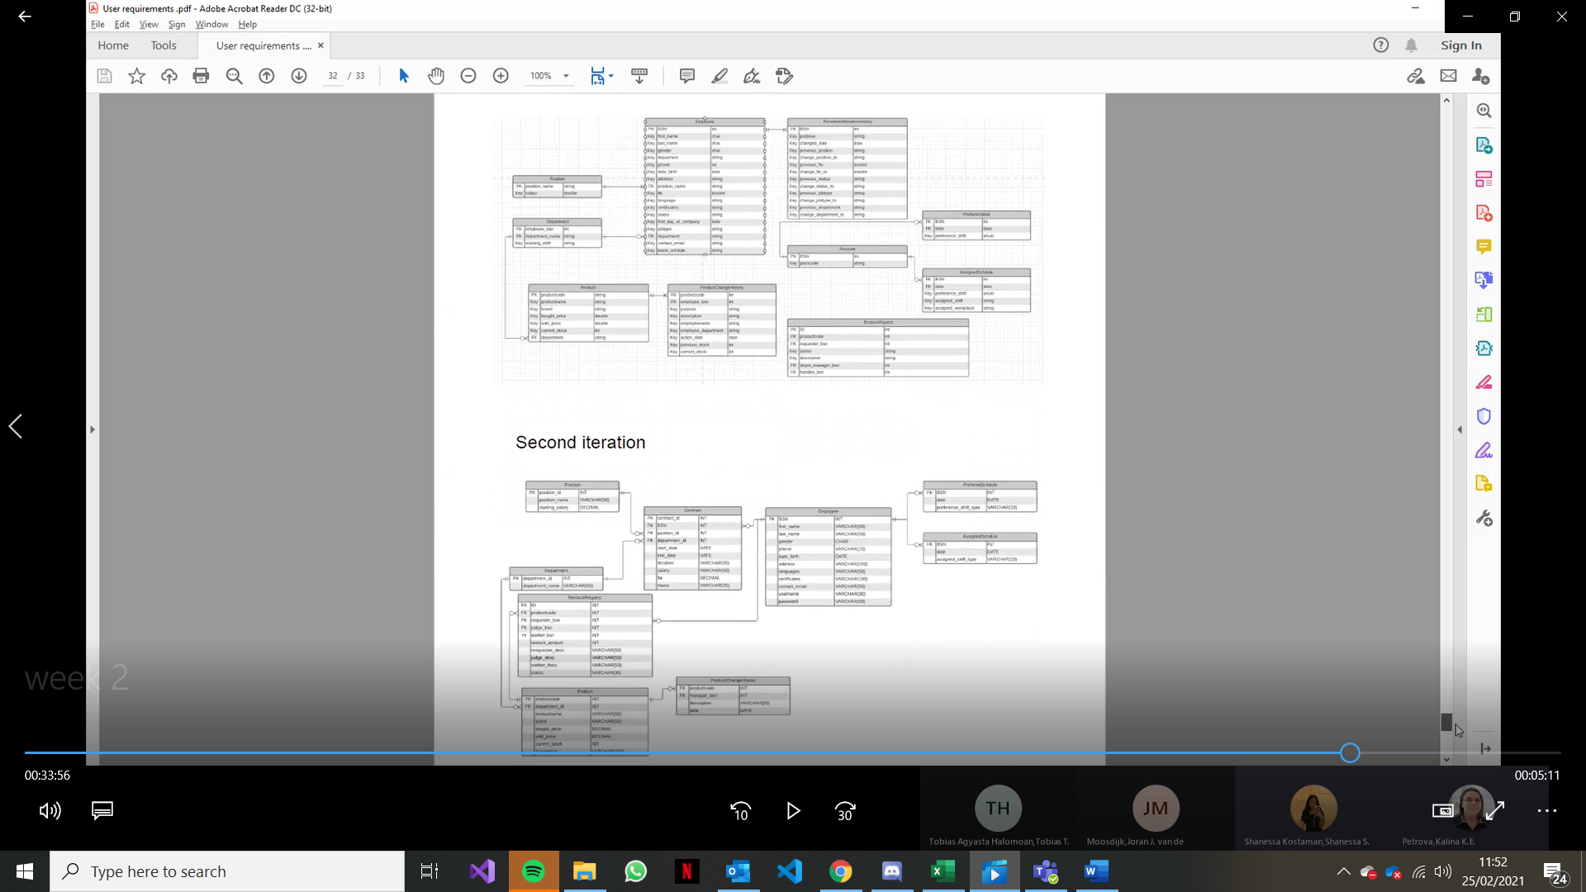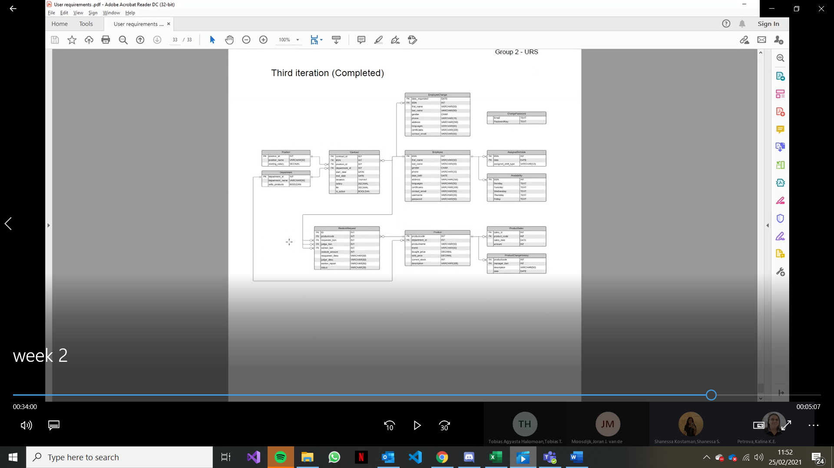

# **Agreements with Client**

In this section we discuss about all the agreement that we’ve made with the client (Frank de Lepper) on Wednesday, 10th February 2021 at 11.00 AM.

**Deliverables**

* **Desktop Application**

We will make the desktop with all the functionality that we discussed and agreed by client.

* **Web Application**

Base on the last meeting with the client, we should provide web application.

* **Database**

The database will store all the data about employee and stock in the warehouse. The database will connect with desktop application and web application and keep both updated to make them synchronized.

* **GUI (Wireframe)**

Before we start to make the application we need to make the wireframe and show them to the client, if the client satisfied with the result we can start to make the application.

* **Application Beta**

We’ll do the demo of the application 1 week before they use the application, so we can do some changes base on feedback from the client.

* **Progress Update**

We will track our progress with gantt chart and keep update the chart to the client, so the client can be sure that we can provide the deliverables according to the phasing.

**End Users**

|  |  |
| --- | --- |
| Employee Manager | The employee manager is responsible to arrange the employee to their shift and which department they belong to. They also need to keep track of the employee. |
| Shop Employees  (Sales worker) | Shop employee only can check the availability of the stock and check their schedule on the application. |
| Stock Manager | The stock manager is responsible to managing (CRUD) of the stock and they also need to keep track the product information and the employee. They also responsible with accepting request for product restock. |
| Stock Employees  (Warehouse worker) | Stock employee is responsible to keep track the availability of the stock and send request to restock the product to the stock manager. They also can check their schedule on the application. |
| Administrator  (HR department) | Administrator are part from the HR Department on the company. They responsible to managing (CRUD) of the employee and |

# Functional Requirements

# Current User Cases

# GUI

# Website Wireframe